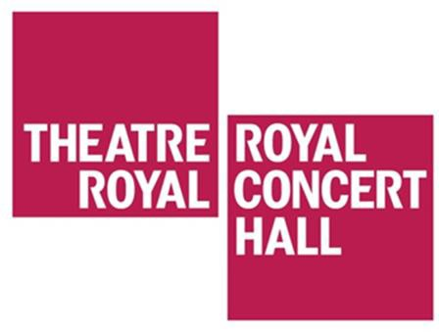

Visual story for travelling to the Theatre Royal and Royal Concert Hall Nottingham from Wollaton Street Blue Badge Parking

The Theatre Royal is approximately 100 meters from Wollaton Street. The Royal Concert Hall is approximately 200 meters from the Wollaton Street.
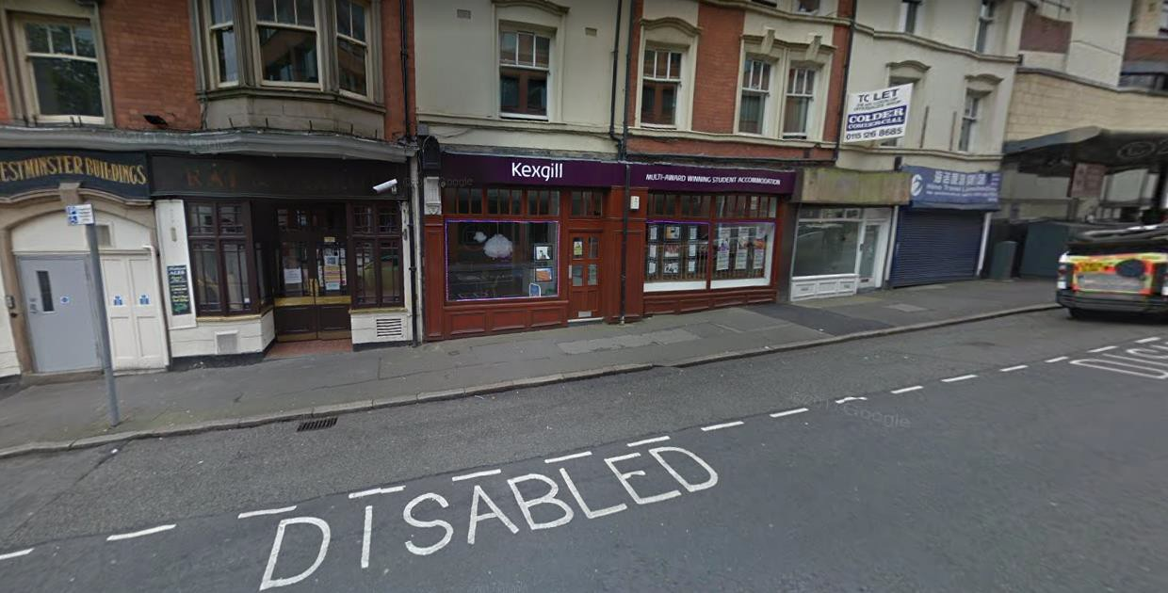
Walk down Wollaton Street towards Goldsmith Street. You will see the Royal Centre tram stop in front of you.

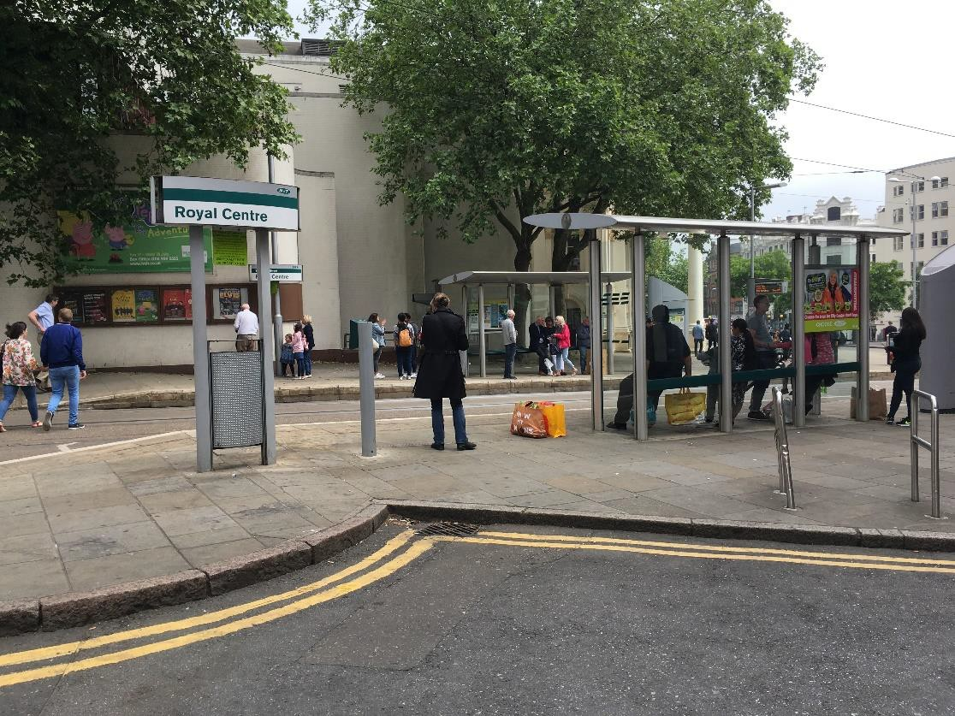

Cross the tram tracks at the public crossing. The Theatre Royal is on your left.
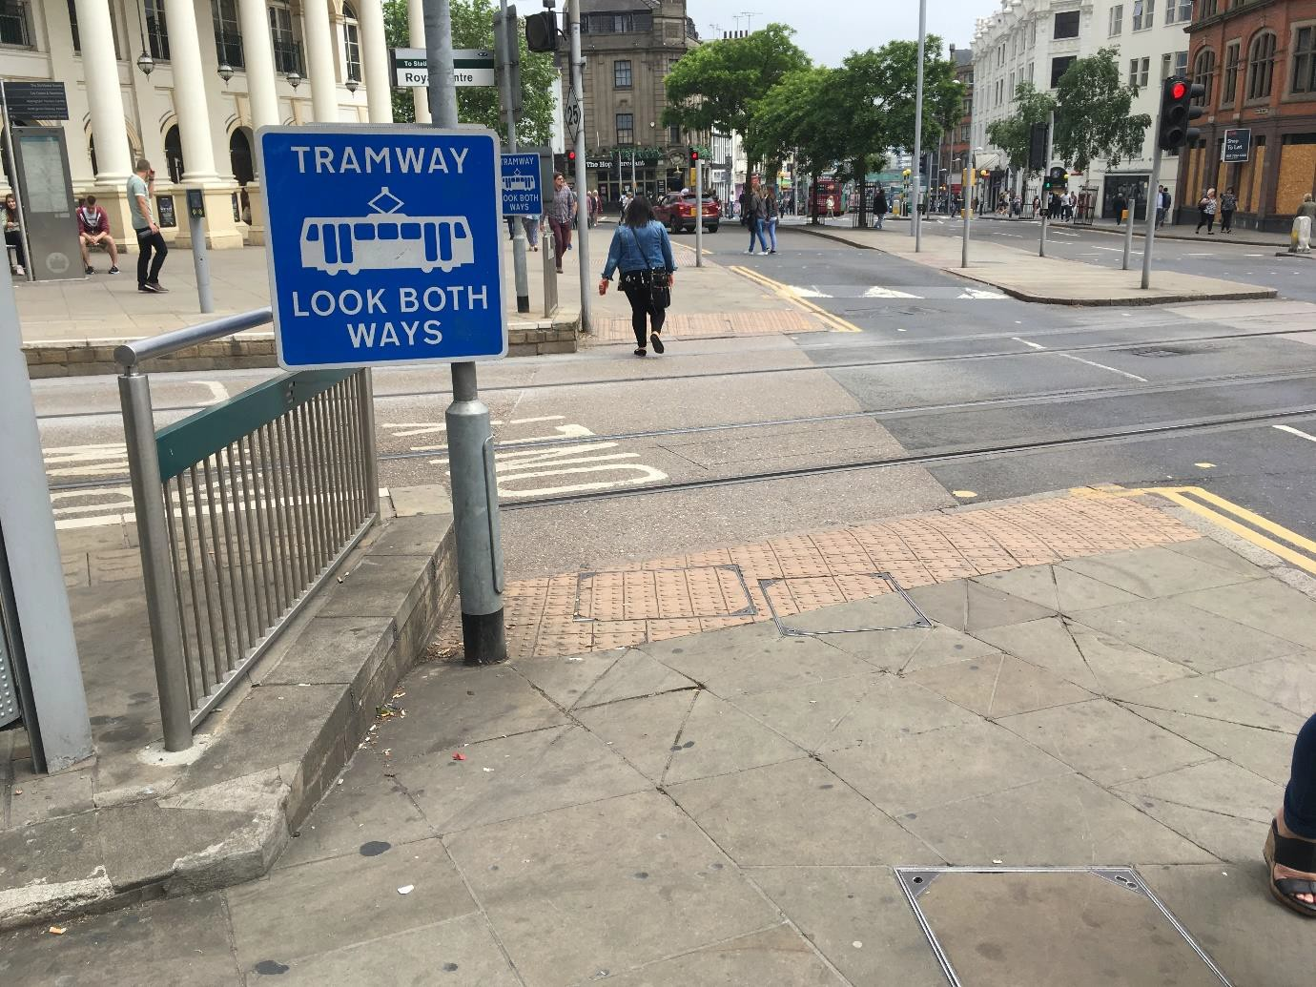
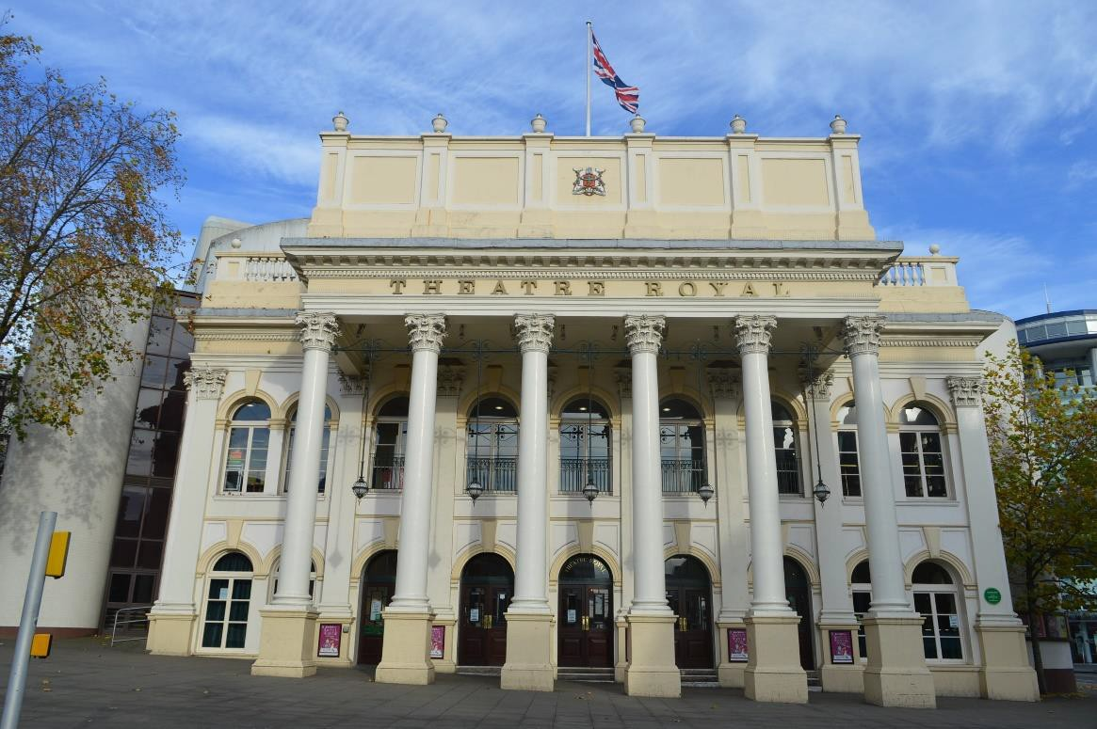
The entrance of the Theatre Royal

To get to the Royal Concert Hall, walk down South Sherwood Street, on the right hand side of the Theatre Royal.
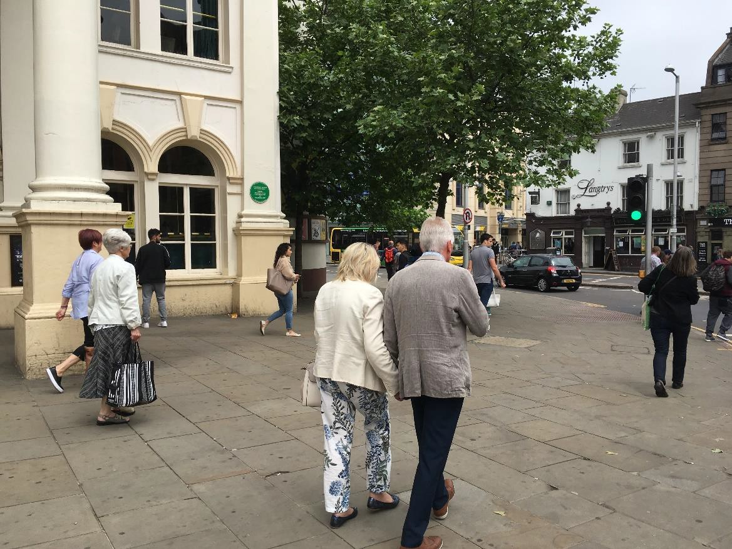
You will walk past Yarn and see the entrance of the Royal Concert Hall.
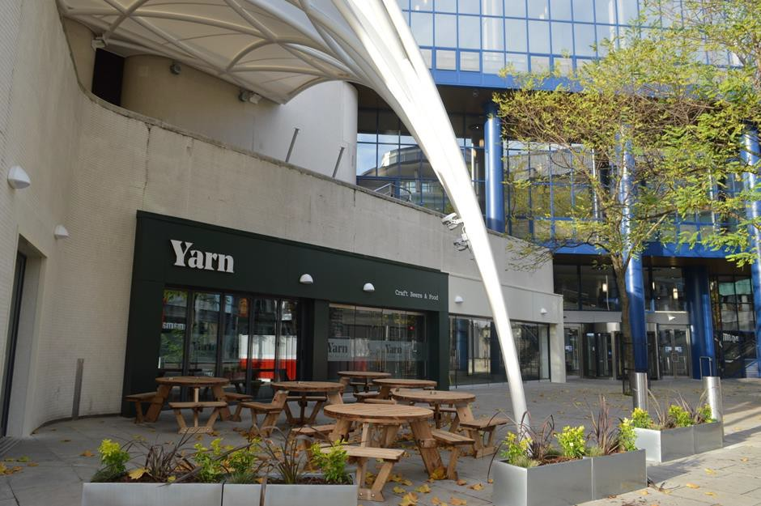

The entrance of the Royal Concert Hall

