Visual Story
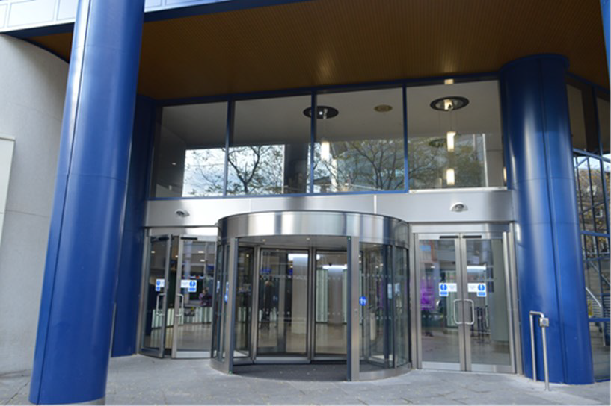
Visiting the
Royal Concert Hall

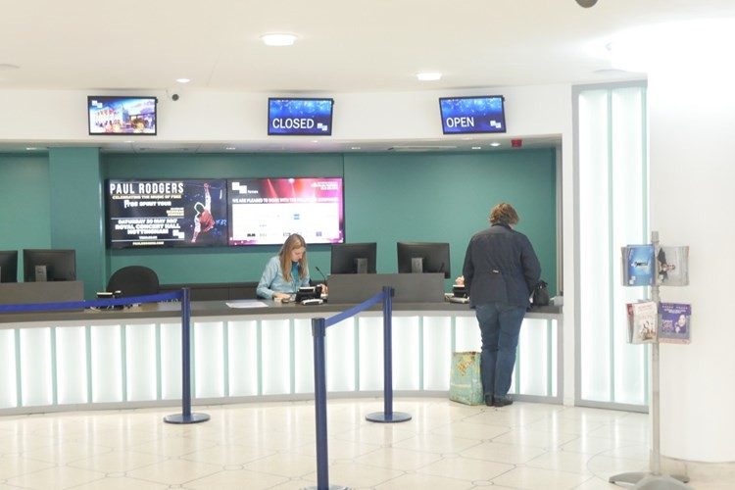
I am going to see a show at the Royal Concert Hall

When I get inside the Royal Concert Hall it may be busy
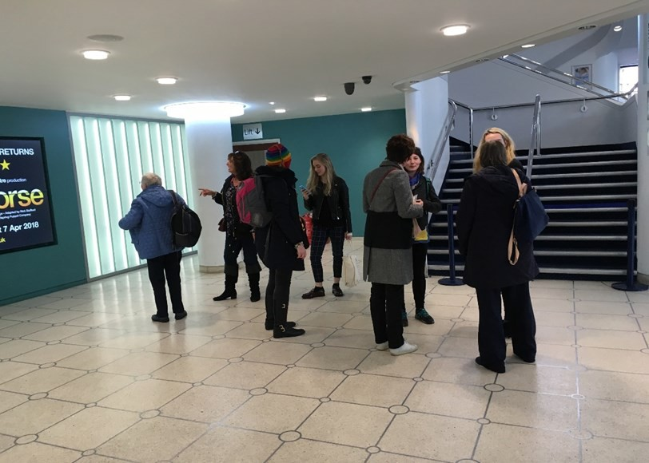

The Royal Concert Hall has five floors in total My seats will be in the Stalls, on Tier 1, or on Tier 2 To get to my seats I may have to climb a few stairs or use the lift.
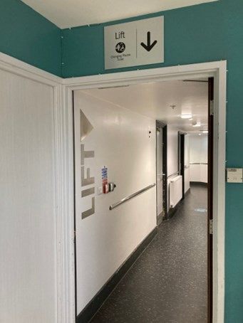
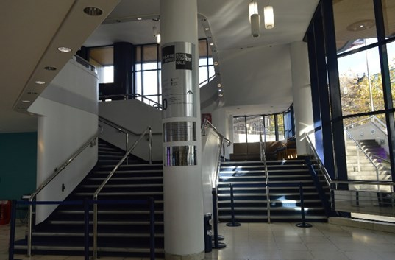

Before we take our seats in the auditorium, I can use the toilet. If I need to use the toilet, I can ask the person
I am with.

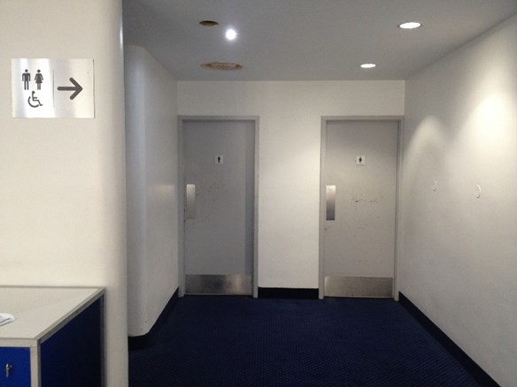
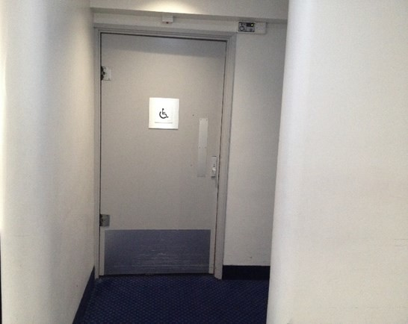

The Theatre Royal and Royal Concert Hall now have a
Changing Places Toilet.

This is located on Level 0 of the Royal Concert Hall. A staff member can direct me to the facility if I am unsure
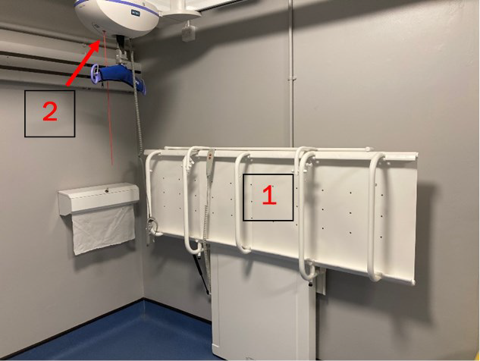
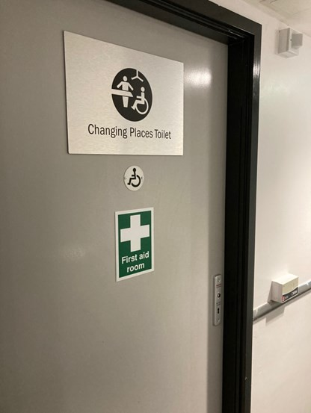
where it is located.

We will show our tickets to a Steward in a uniform who will look like this:

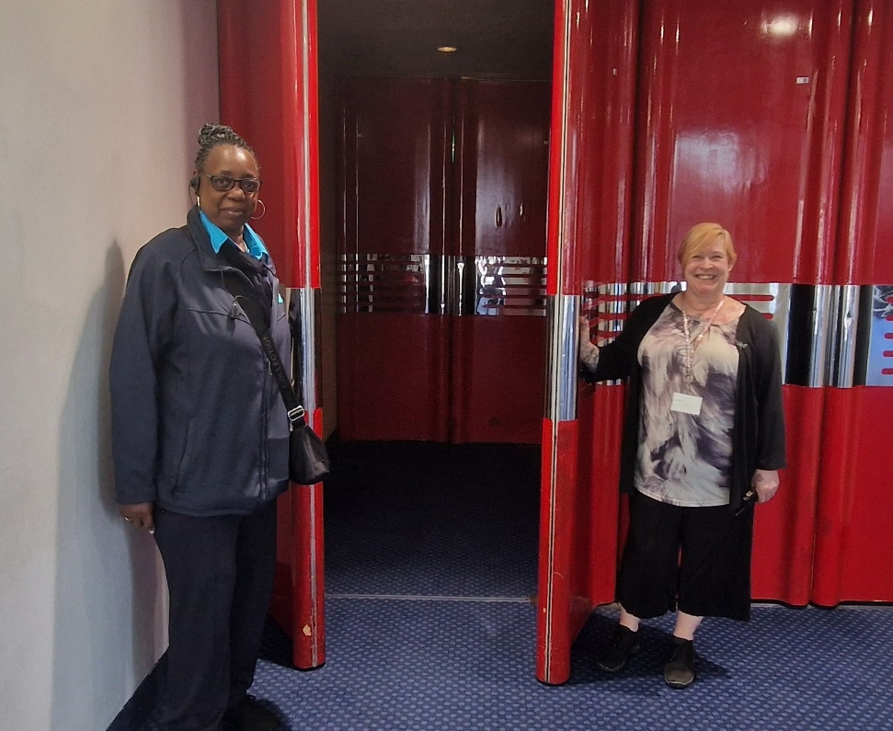

The Steward will look at our tickets and tell us where we need to go.
The letters and numbers on the tickets tell us where we need to sit. It is not a choice.
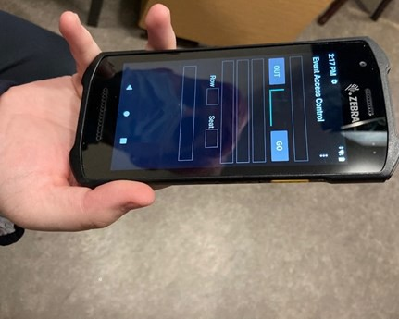
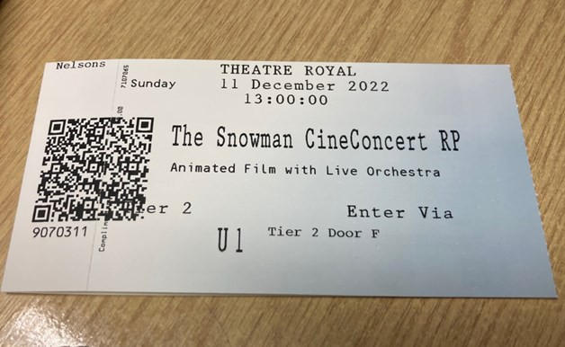

The Steward will scan our QR code with their device and it will make a ‘beep’ sound.

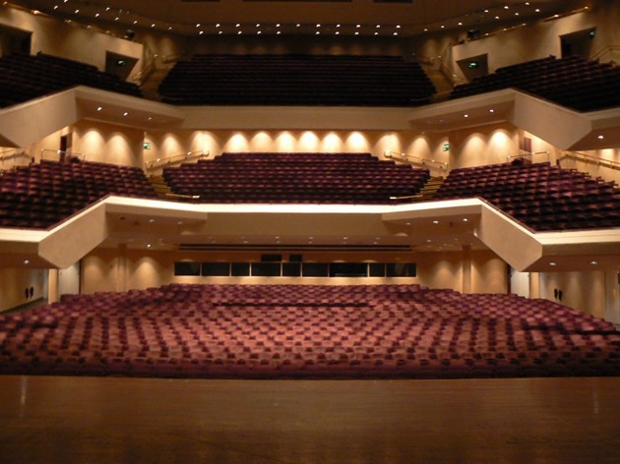
Then we will go inside the auditorium. The Royal Concert Hall is very big and there are lots of seats!

My seat will look like this:
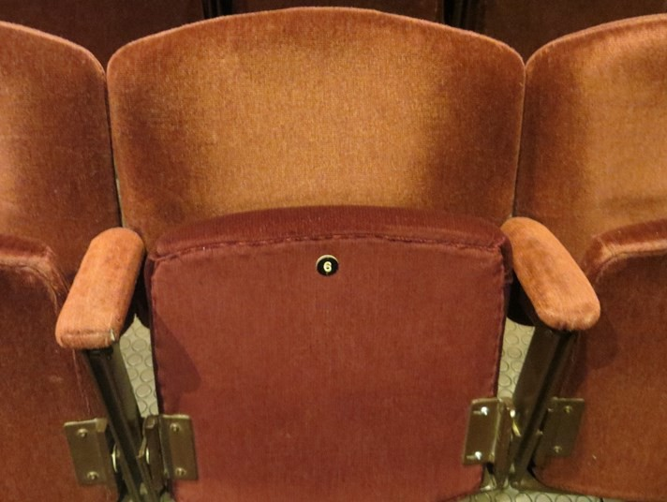
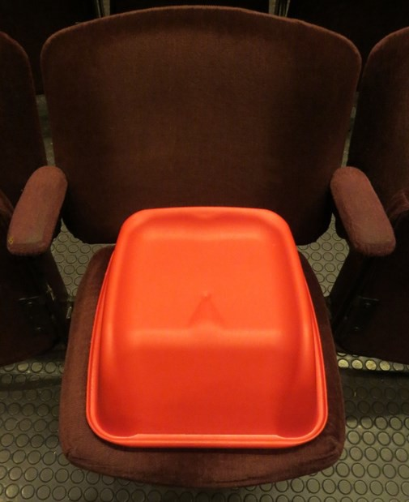
If I can’t see the stage clearly, I can aske an adult for a booster seat to sit on.

When it is time for the show to start, a voice will ask
everyone to turn off their mobile phones.
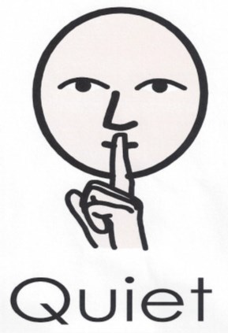
The Royal Concert Hall will get darker and everyone needs to be quiet.
When the show starts, I will see performers coming on to the stage. I will try and be as quiet as I can so I can
hear everything.
Seeing a show at the Royal Concert Hall is a bit like seeing something on TV or in a film, but the people are right there in front of you on the stage.
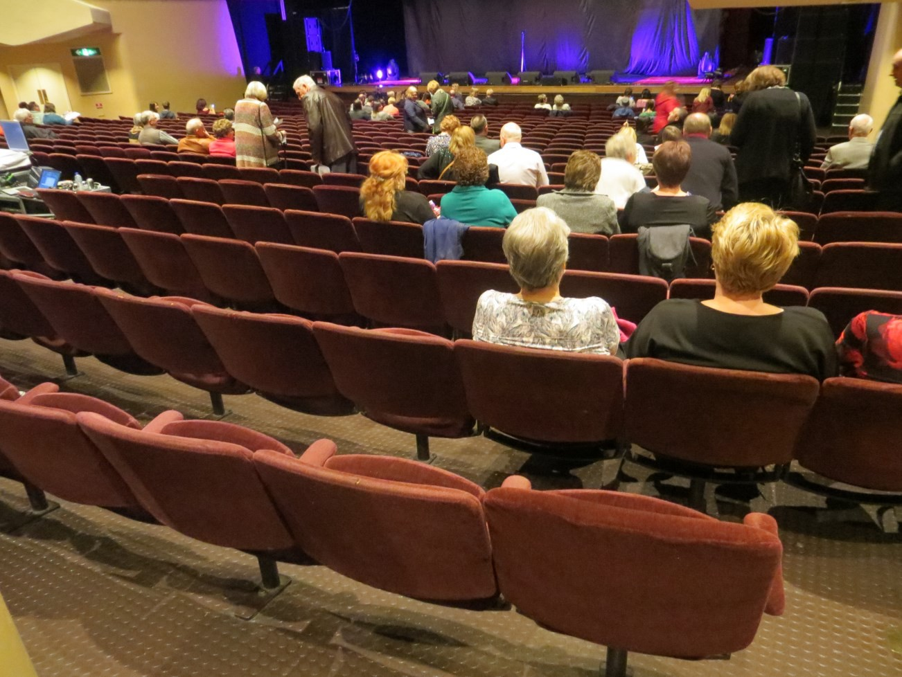

Sometimes, parts of the show can be loud.

If the sound bothers me, I can put my hands over my ears or wear my ear defenders.

In the middle of the show there is a break This is called
the interval.
I can use the toilet or buy a drink or snack from the kiosk.
The interval is usually 20 minutes.


After the interval everyone will come back and sit down in their seats again.
It will get darker and quieter again just like at the beginning of the show.
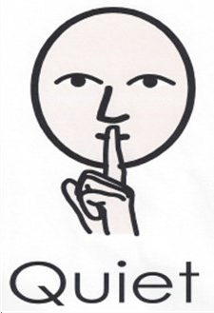
At the end of the show, the performers may come out on to the stage and bow.
Many people will clap and cheer to show the performers
how much they liked the show.
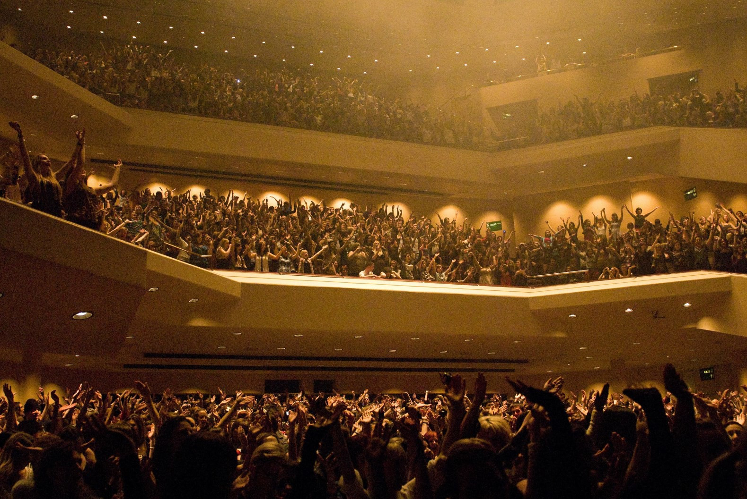


If I want to clap I can.
If the clapping is too loud, I can cover my ears or wear my ear defenders.

After the show has finished, we will leave the Royal Concert Hall.

