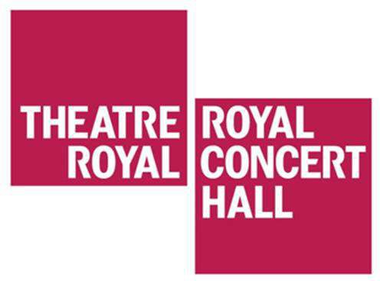

Visual story for travelling to the Theatre Royal and Royal Concert Hall Nottingham Victoria Bus Station

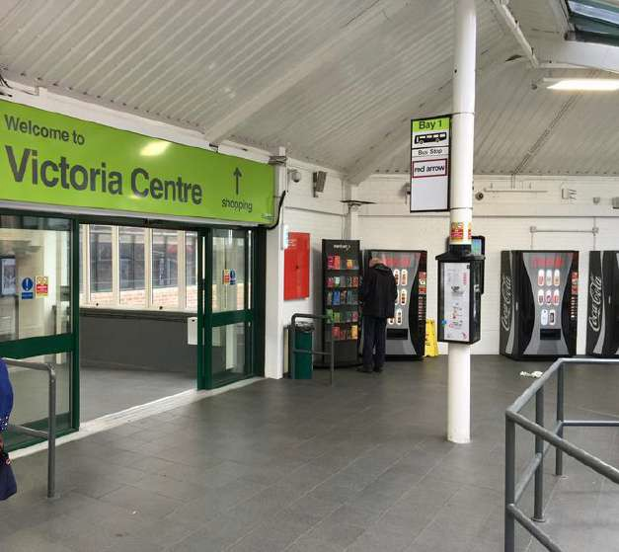
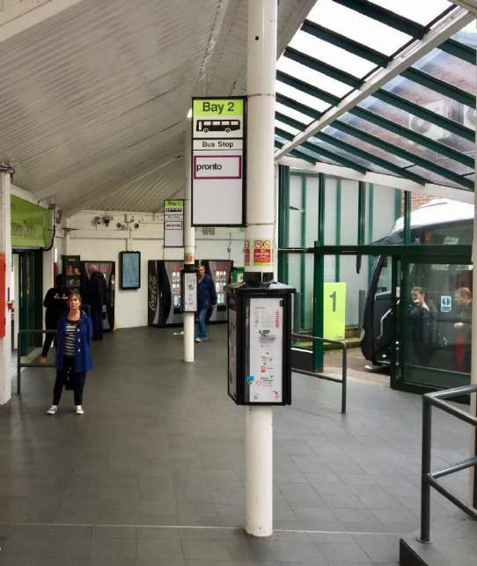
The Theatre Royal and Royal Concert Hall is 640 meters from Victoria bus station.

Exit the bus station via the tunnel to Victoria Centre.

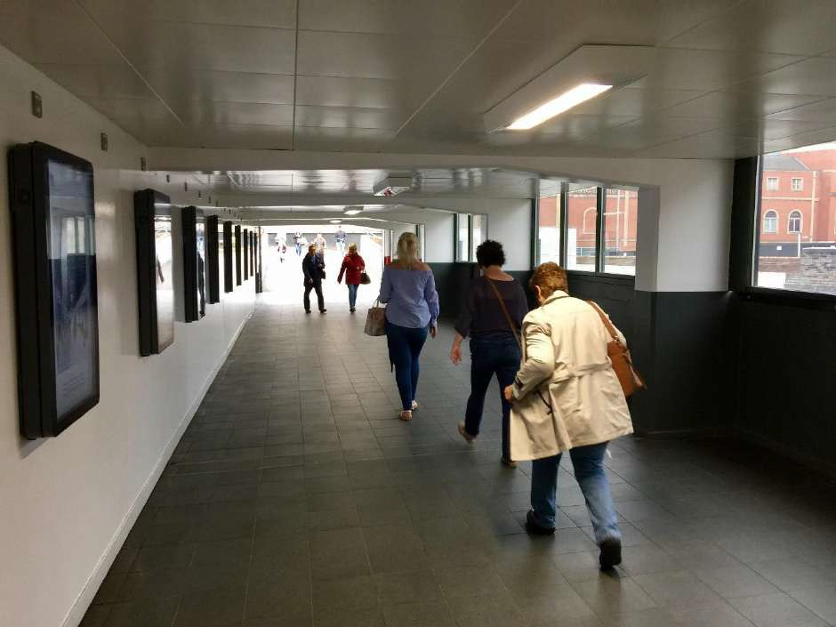
Upon exiting the tunnel, turn right onto York Street. You will pass some black and yellow bollards and the entrance of the Victoria Centre Car Park.

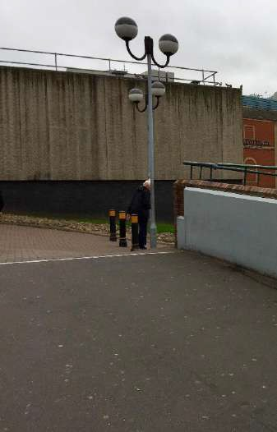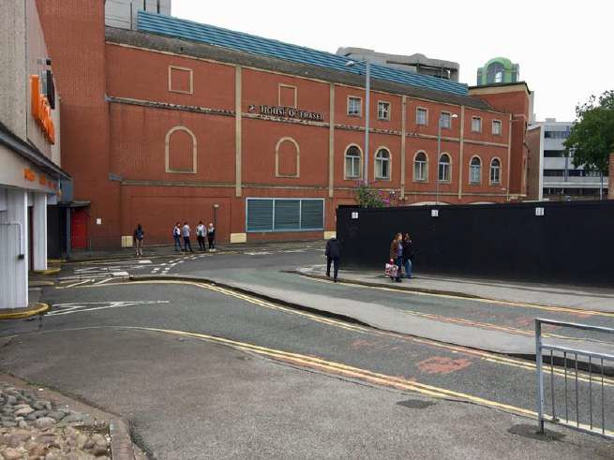

Turn right on to Union Street.
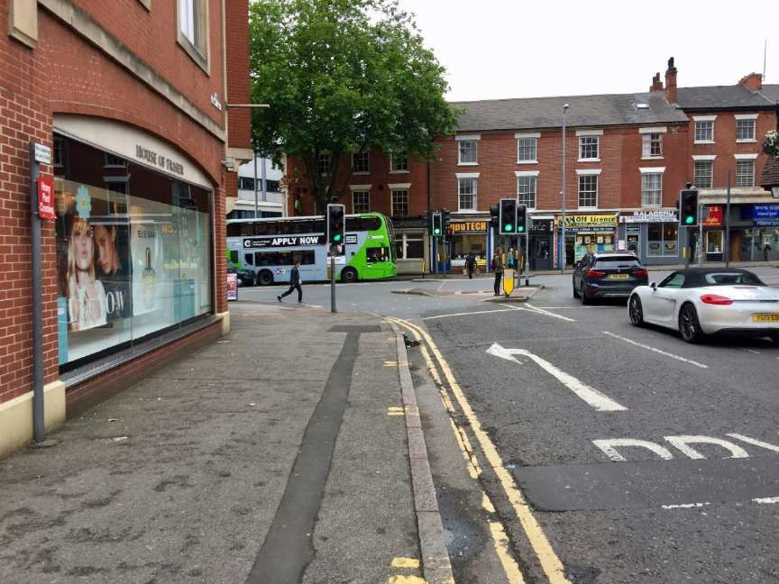
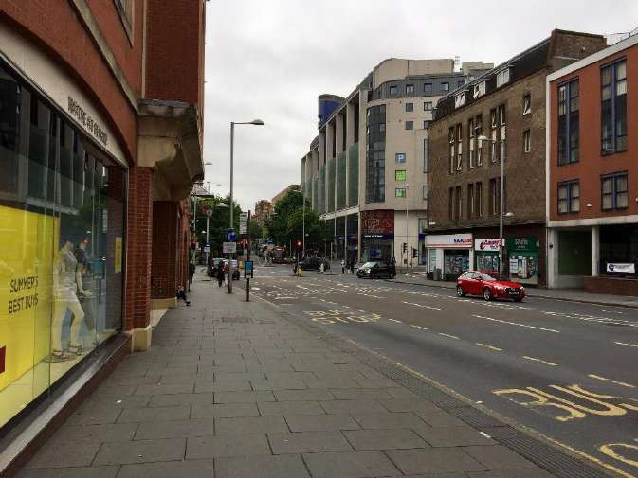
At the end of Union Street, turn left on to Mansfield Road.

Turn right on to Shakespeare Street.
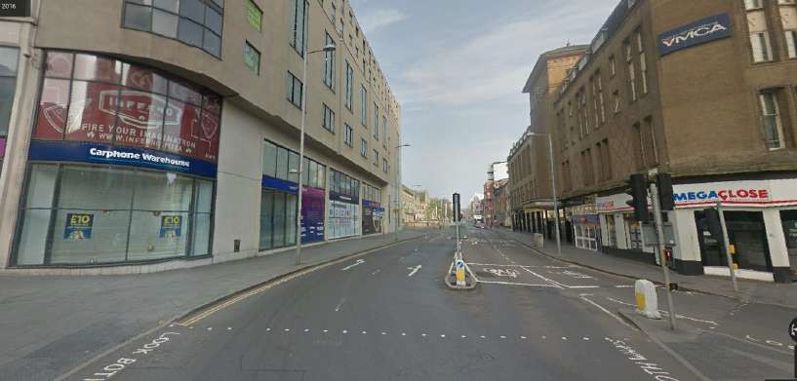
Continue to walk up Shakespeare Street and turn left on to North Church Street. You will walk past the entrance of Trinity Square Car Park.

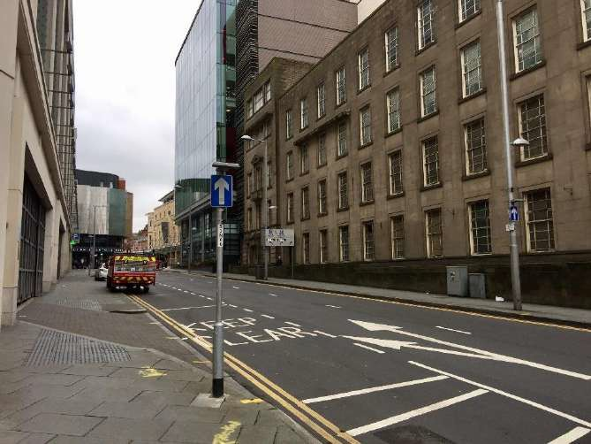

North Church Street curves to the right and becomes Burton Street. Continue walking up Burton Street.
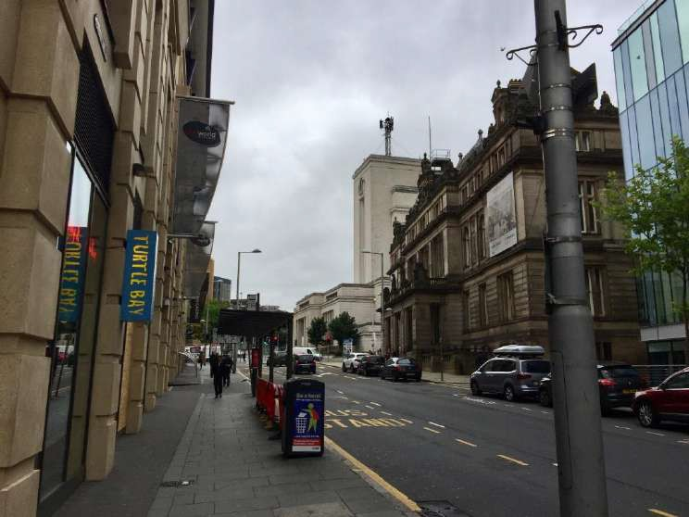
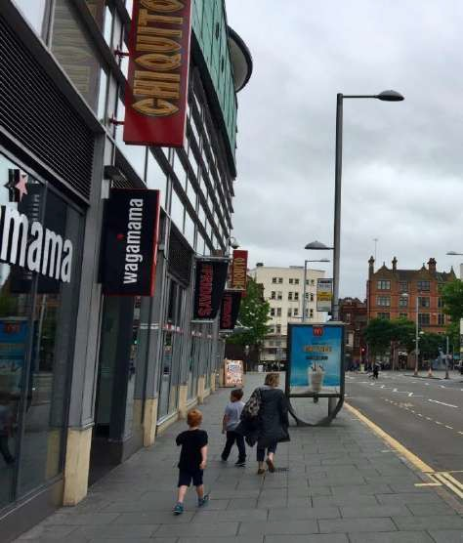
At the end of Burton Street, turn left onto South Sherwood Street. You will see the Royal Concert Hall on your right.

Use the pedestrian crossing to cross South Sherwood Street.
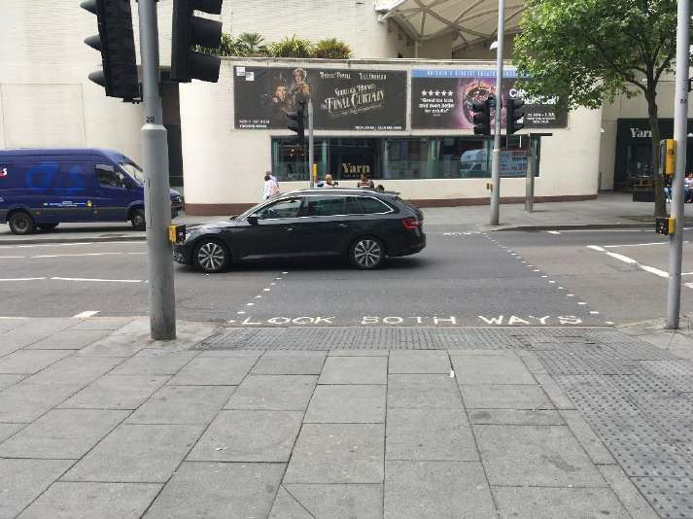
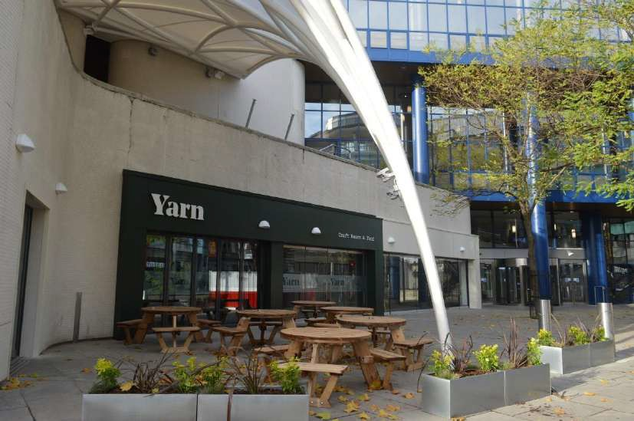
You will see the entrance to Yarn and the Royal Concert Hall.

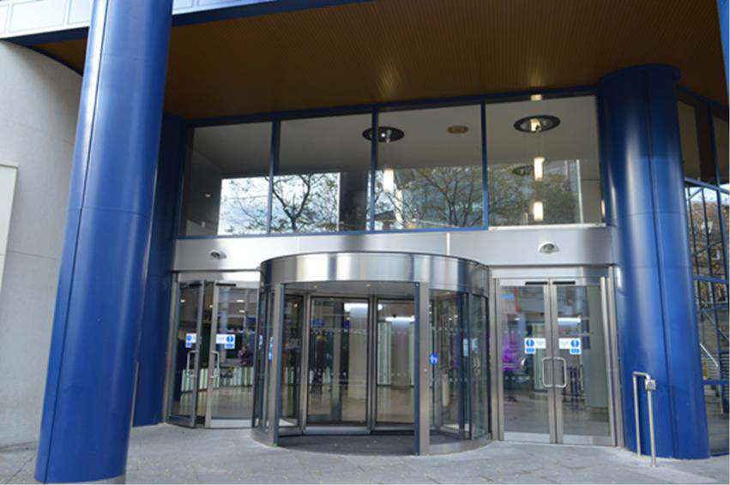
The entrance of the Royal Concert Hall
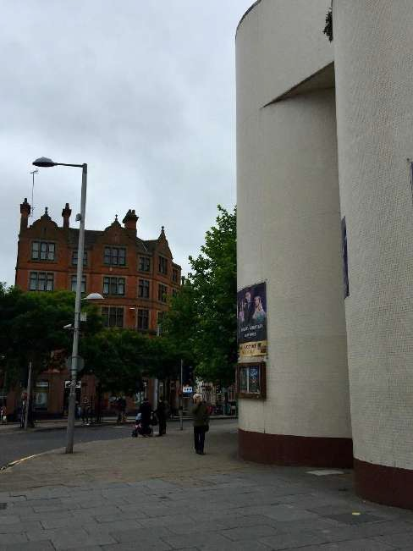
To get to the Theatre Royal, turn left and continue walking up South Sherwood Street.

Turn right on Upper Parliament Street, you will see the entrance to the Theatre Royal.
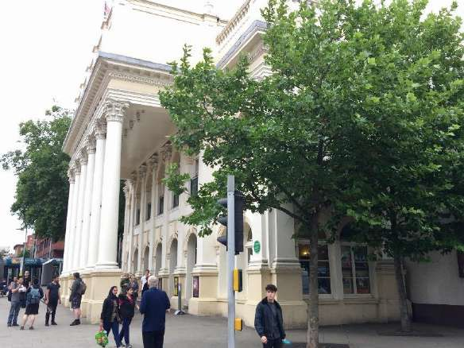
The entrance of the Theatre Royal

