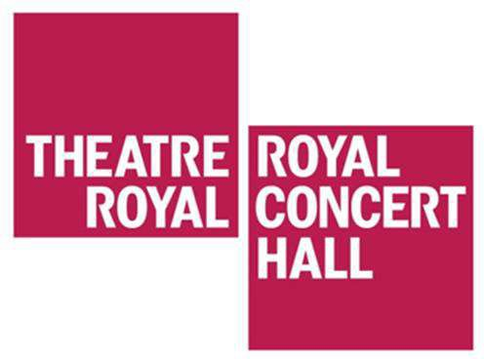

Visual story for travelling to the Theatre Royal and Royal Concert Hall Nottingham from Nottingham Train Station

The Theatre Royal and Royal Concert Hall is
0.7 miles from Nottingham Train Station.

Leave the train station through the glass doors labelled ‘Exit to Station Street and City Centre’. There is a Starbucks opposite the glass doors.

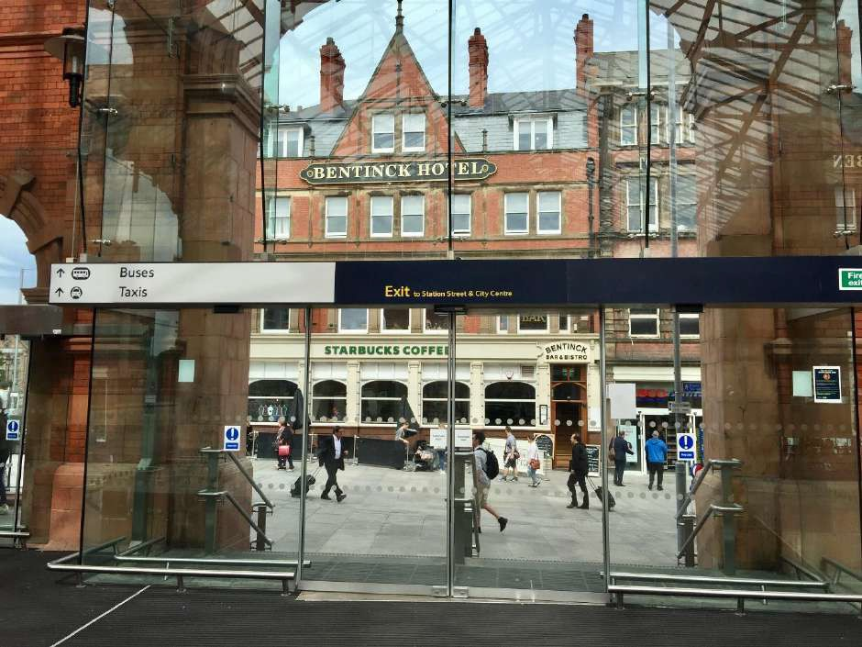

Walk up Carrington Street, towards Broadmarsh shopping centre.

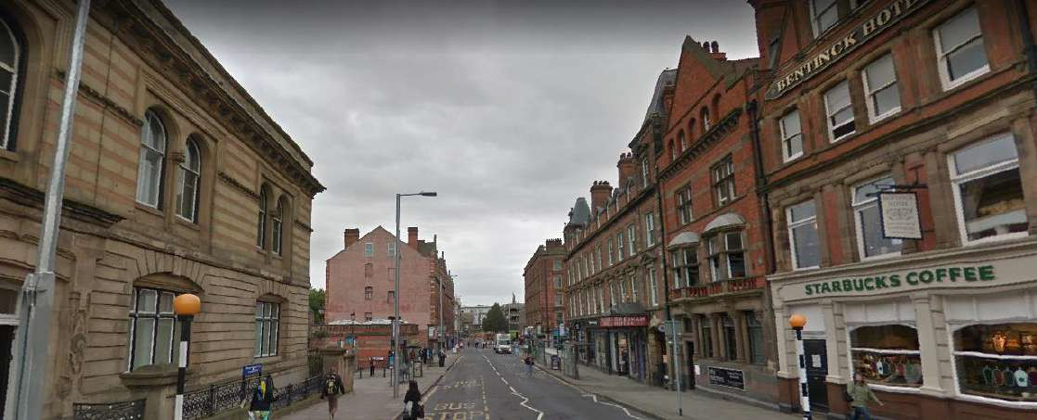
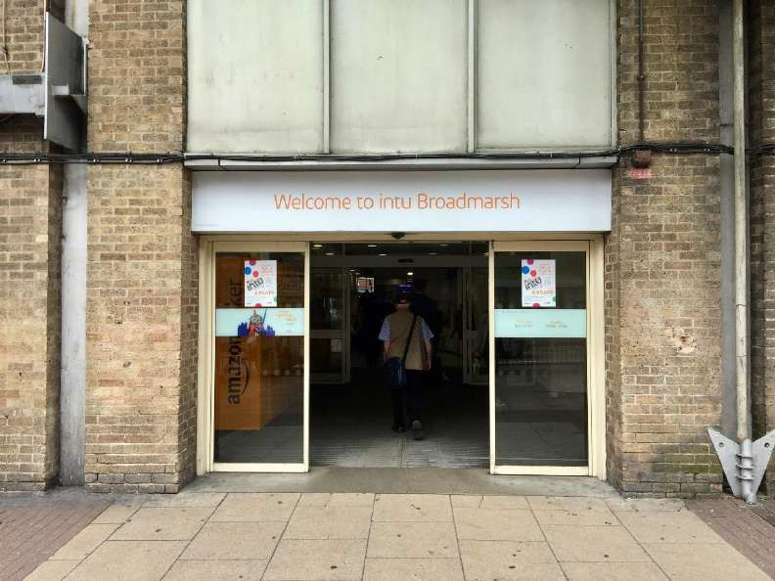
Enter Broadmarsh Shopping Centre

Walk through Broadmarsh shopping centre out onto Lister Gate.

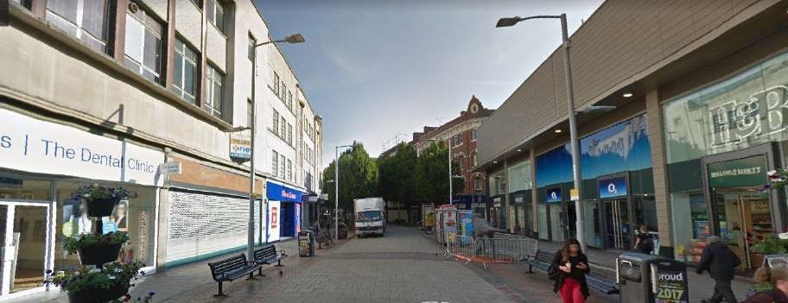

Continue to walk up Lister Gate until you reach St Peter’s Church and the Marks and Spencer.

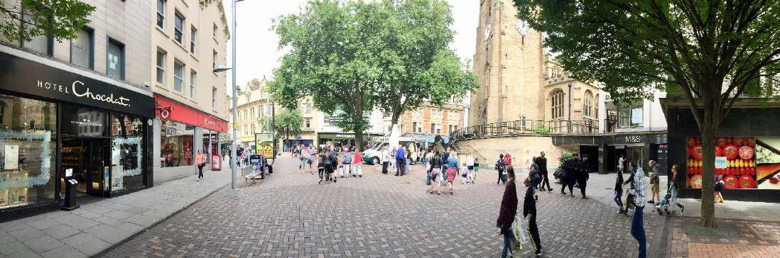

Turn left onto Wheeler Gate
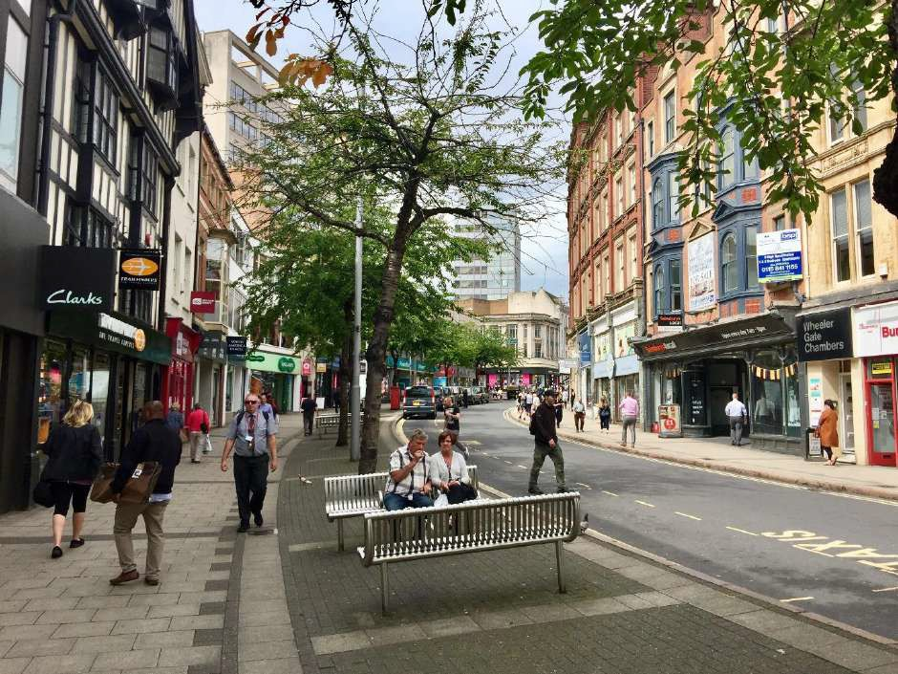
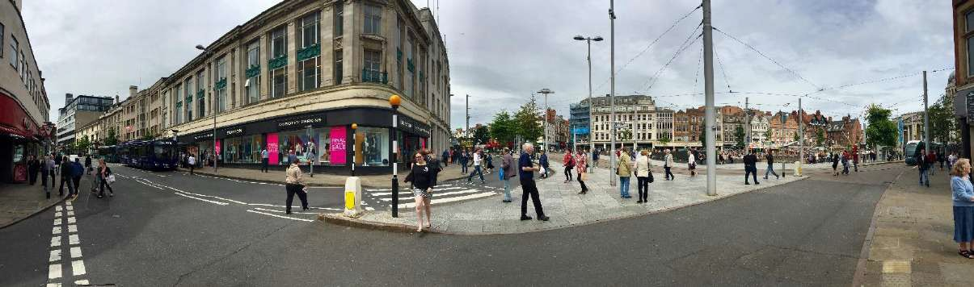
Continue to walk up Wheeler Gate until you reach the Market Square

From the Market Square, walk up Market Street.
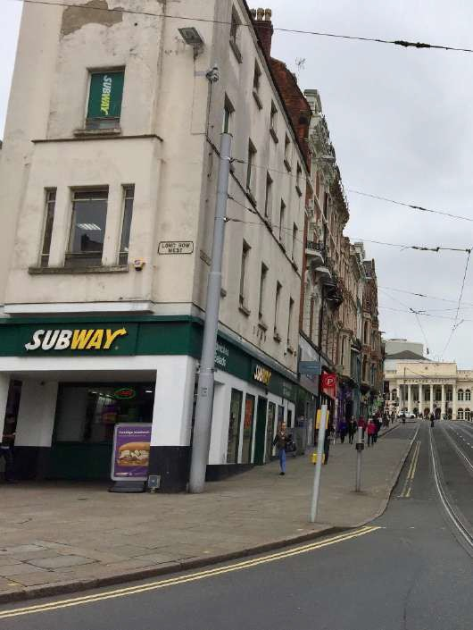
The front of the Theatre Royal can be seen from the end of Market Street

Continue to walk up Market Street
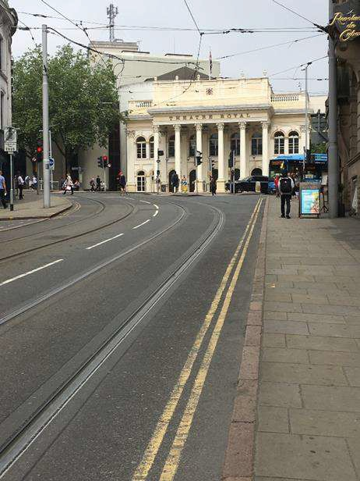
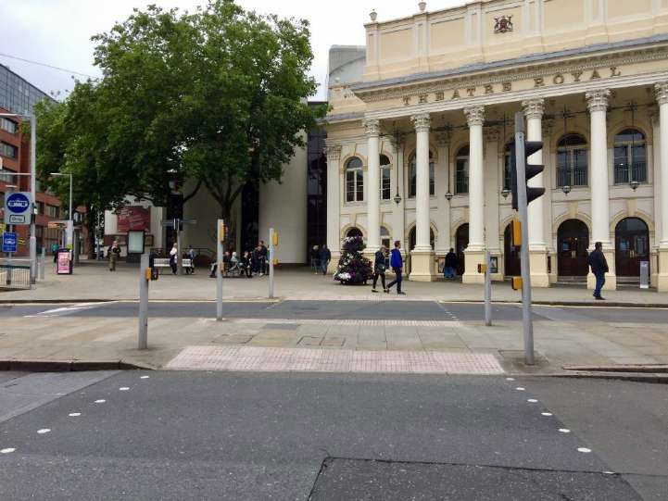
Use the pedestrian crossings to cross Upper Parliament Street.

The entrance to the Theatre Royal is on Upper Parliament Street.
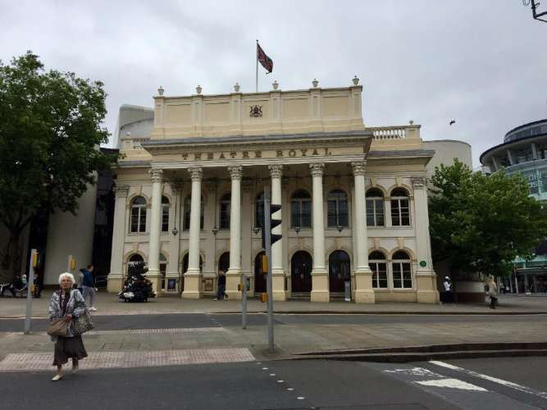
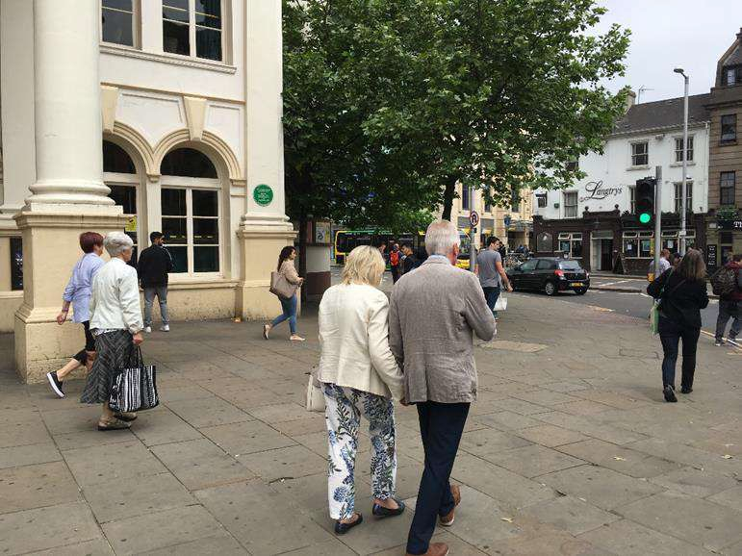
To get to the entrance of the Royal Concert Hall, walk down South Sherwood Street on the right hand side of the Theatre Royal.

You will walk past our Café bar, Yarn.
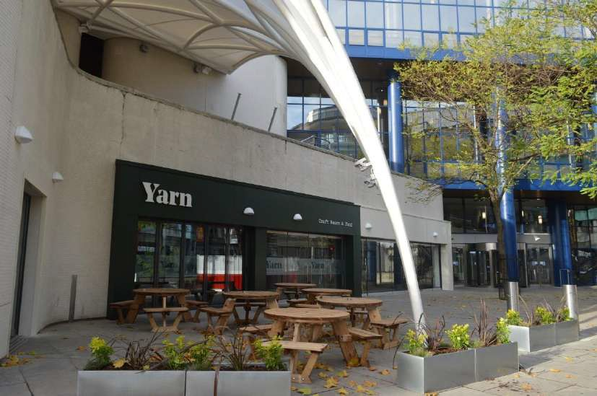
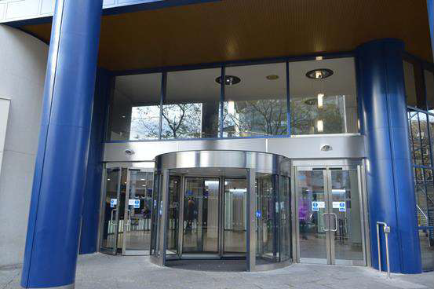
The entrance of the Royal Concert Hall is on South Sherwood Street

