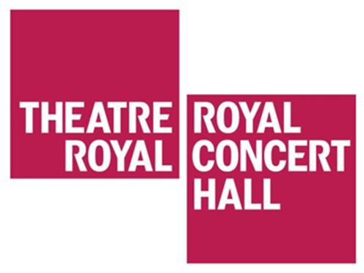

Visual story for travelling to the Theatre Royal and Royal Concert Hall Nottingham from Q-Park Car Park

Q-Park multi-storey car park is located on Stanley Place, just off Talbot Street. The Theatre Royal is approximately 320 meters from Q-Park. The Royal Concert Hall is approximately 320 meters from Q-Park
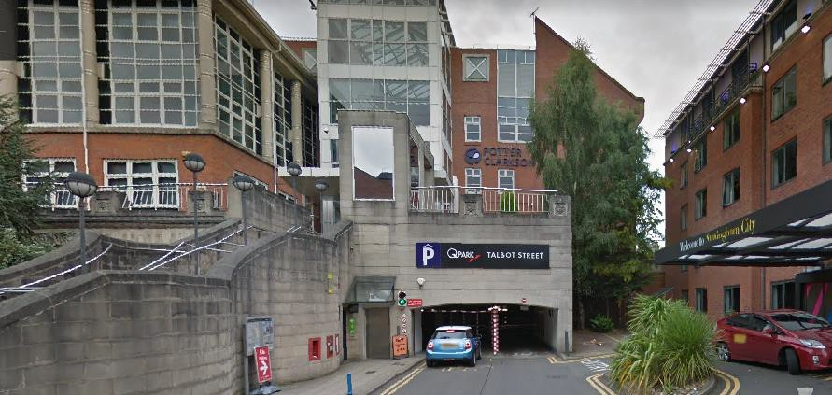
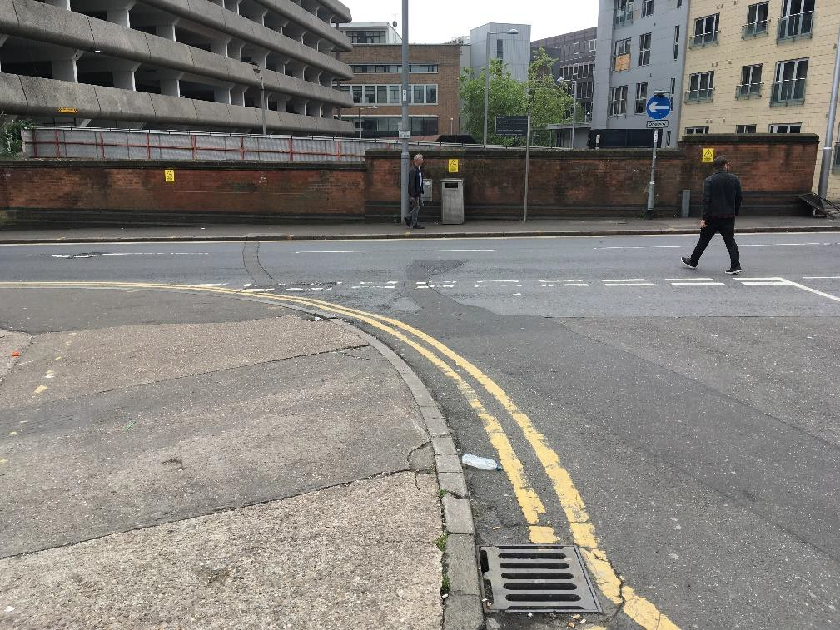
Exit the car park and walk down Stanley Place.

Turn left onto Talbot Street.
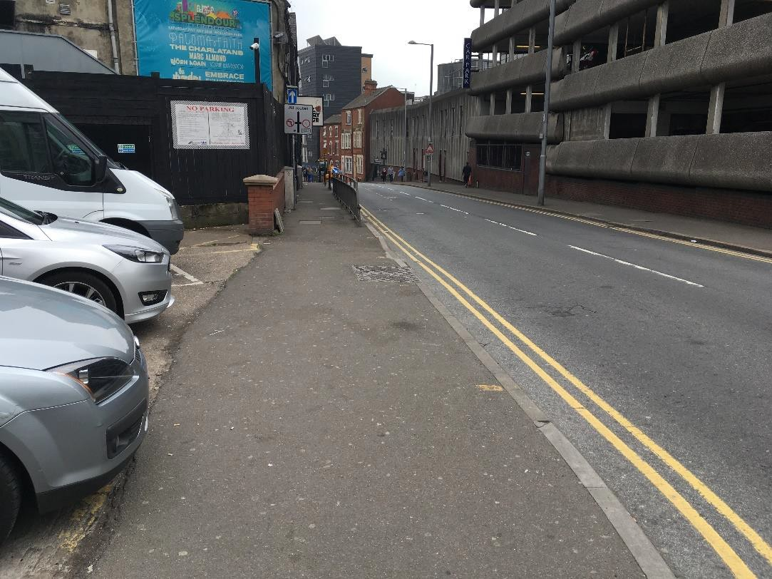
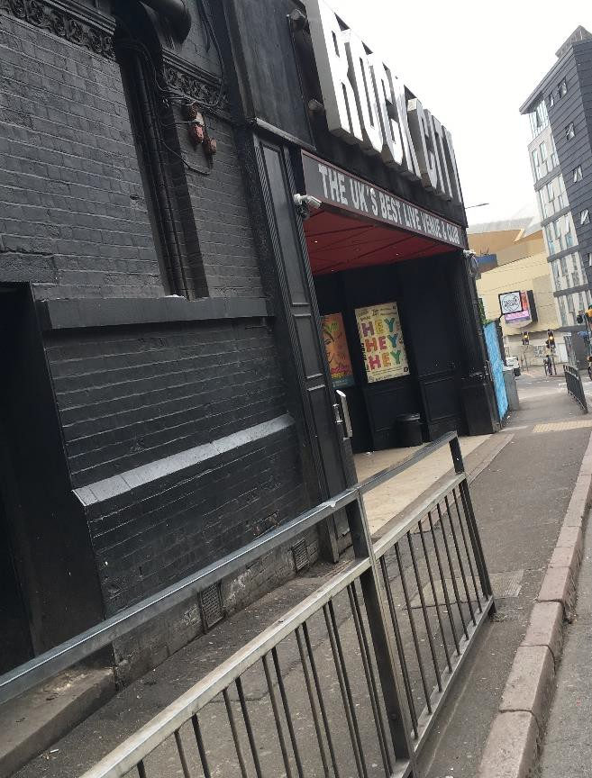
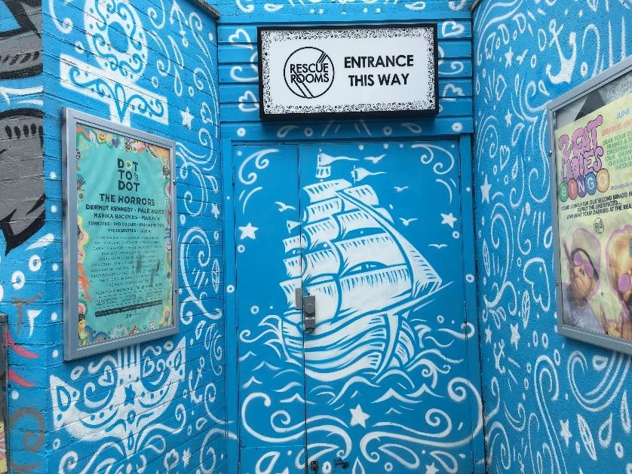
Continue to walk down Talbot Street, past Rock City and Rescue Rooms.

You will reach a set of traffic lights at the end of Talbot Street and will see the back of The Royal Concert Hall.
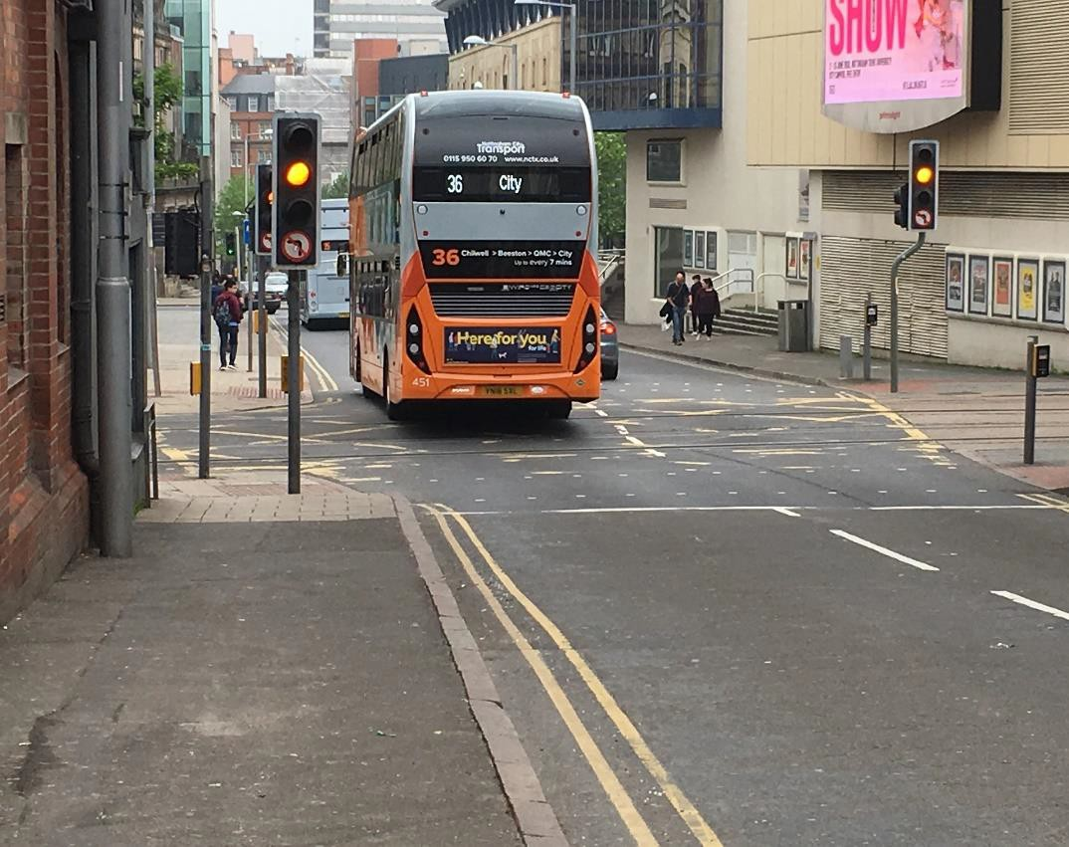
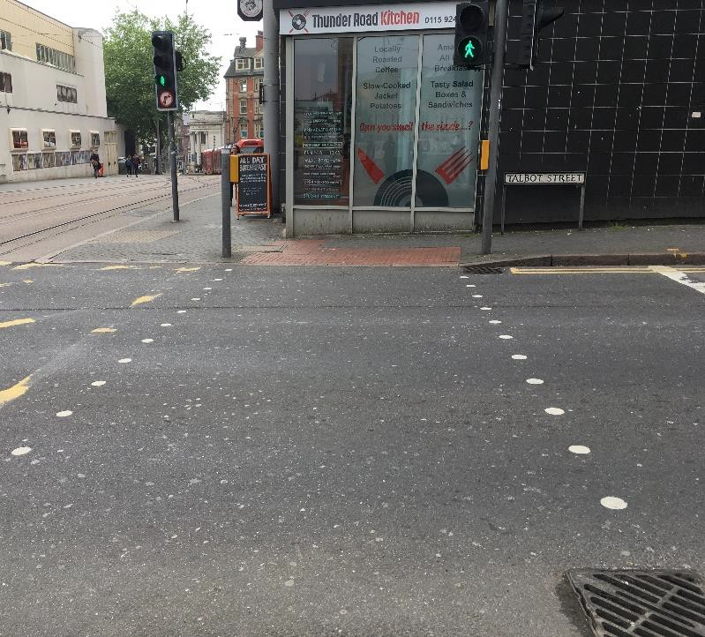
Cross Talbot Street using the pedestrian crossing. You will now be on Goldsmith Street.

Cross Goldsmith Street towards the back of The Royal Concert Hall. You will now be on Burton Street.
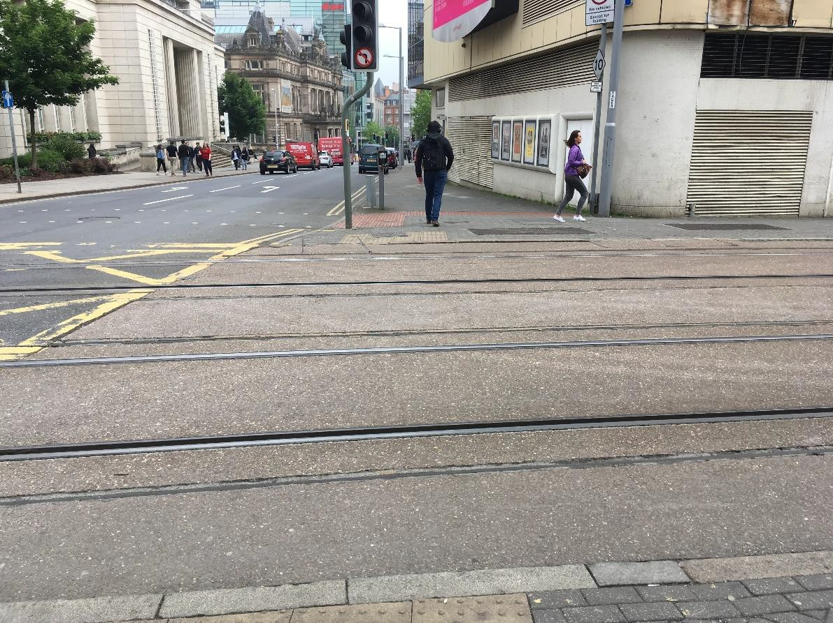

Continue to walk down Burton Street.
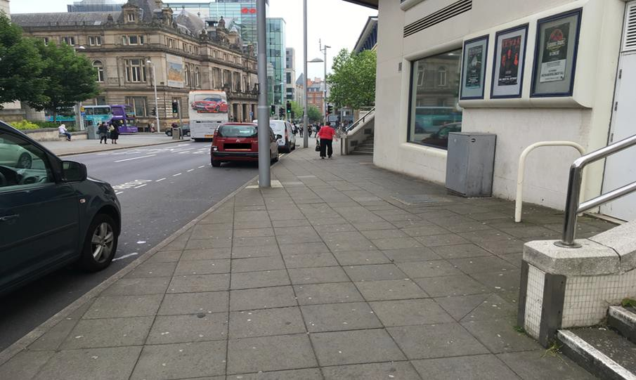

The ramped entrance to The Royal Concert Hall will be on your right.
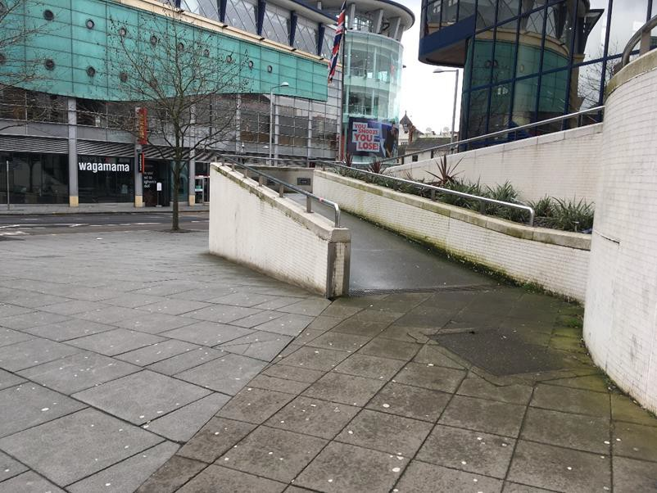
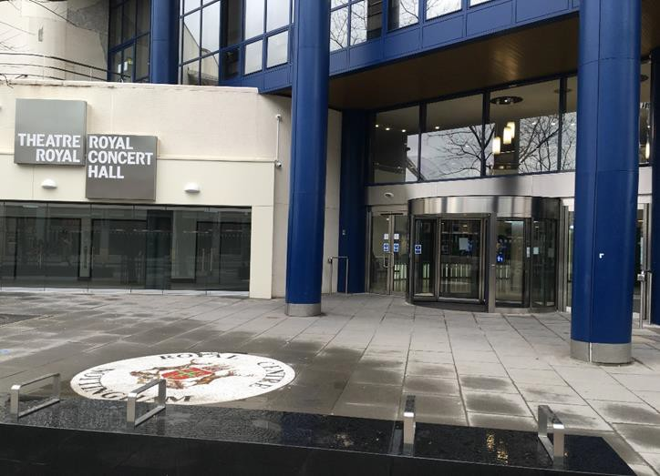
Turn right onto South Sherwood Street.

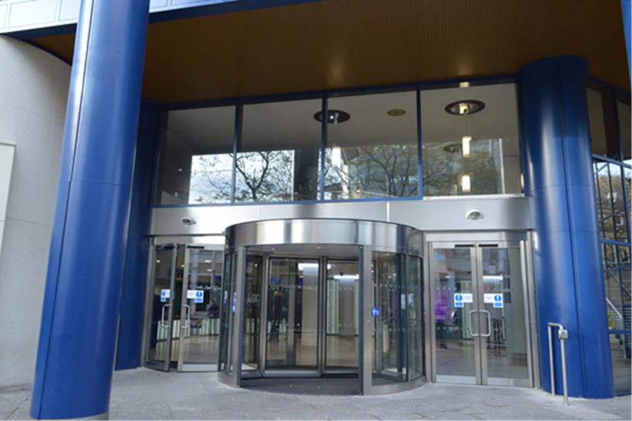
The entrance to The Royal Concert Hall is on South Sherwood Street.
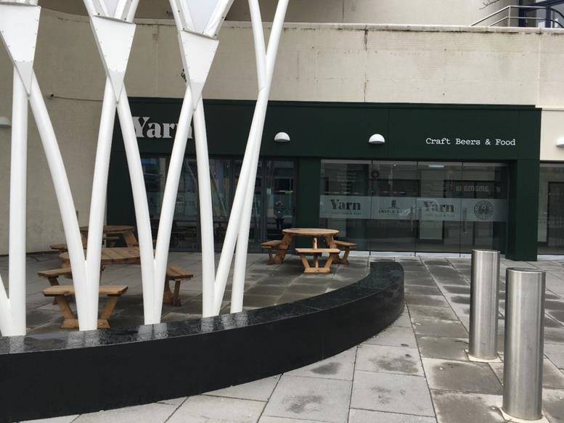
To get to the entrance of The Theatre Royal, Continue to walk down South Sherwood Street, past Yarn.

Turn right onto Upper Parliament Street.
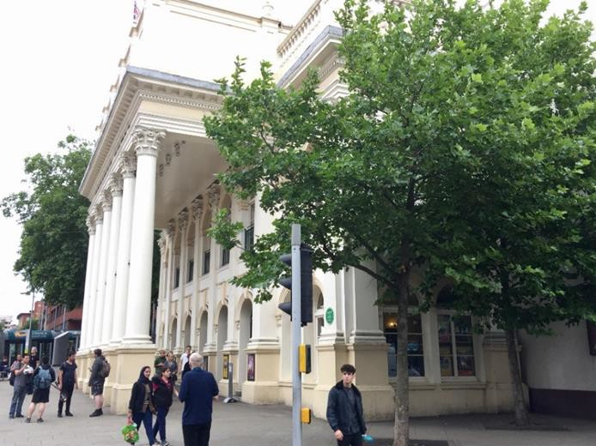
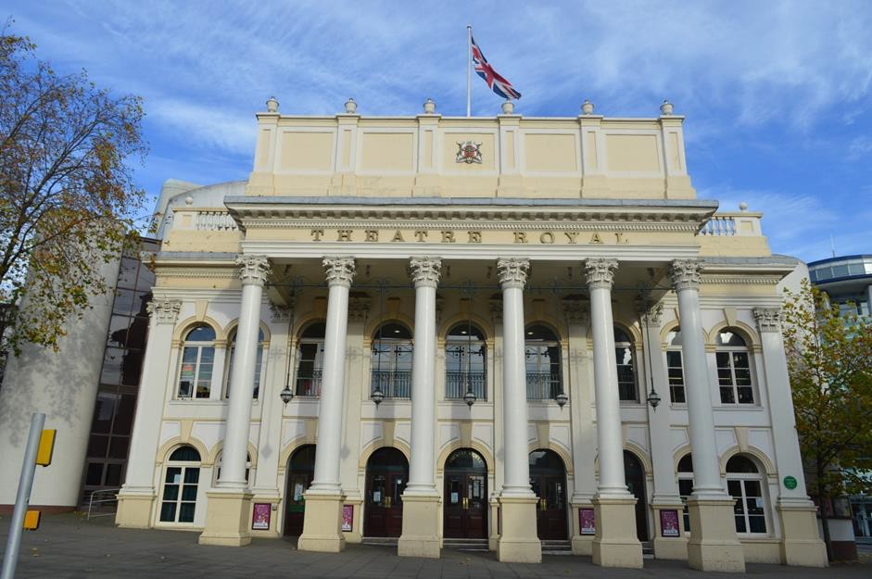
The entrance to the Theatre Royal is on Upper Parliament Street.

