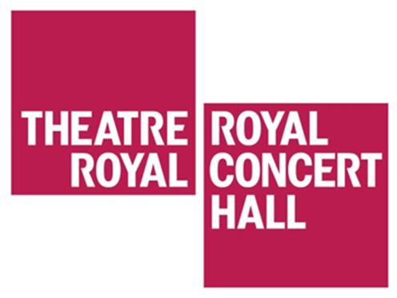

Visual story for travelling to the Theatre Royal and Royal Concert Hall Nottingham from Burton Street Blue Badge Parking

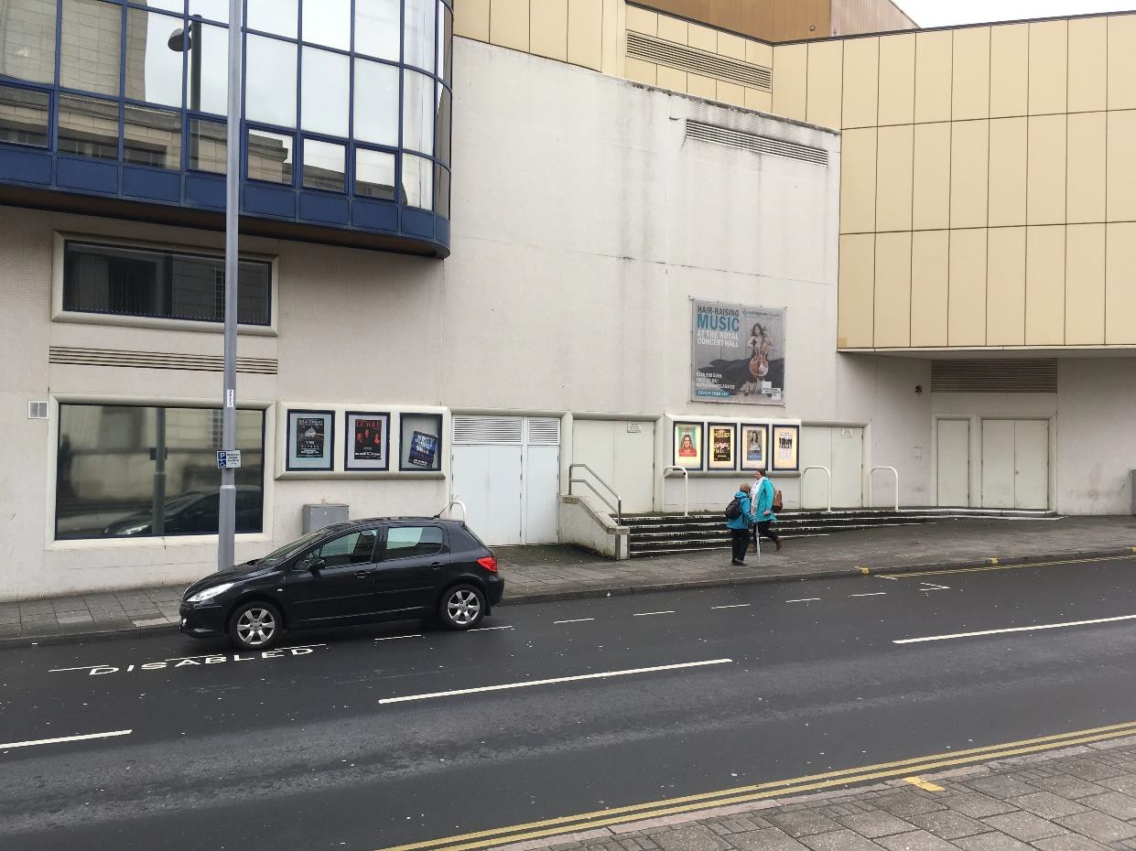
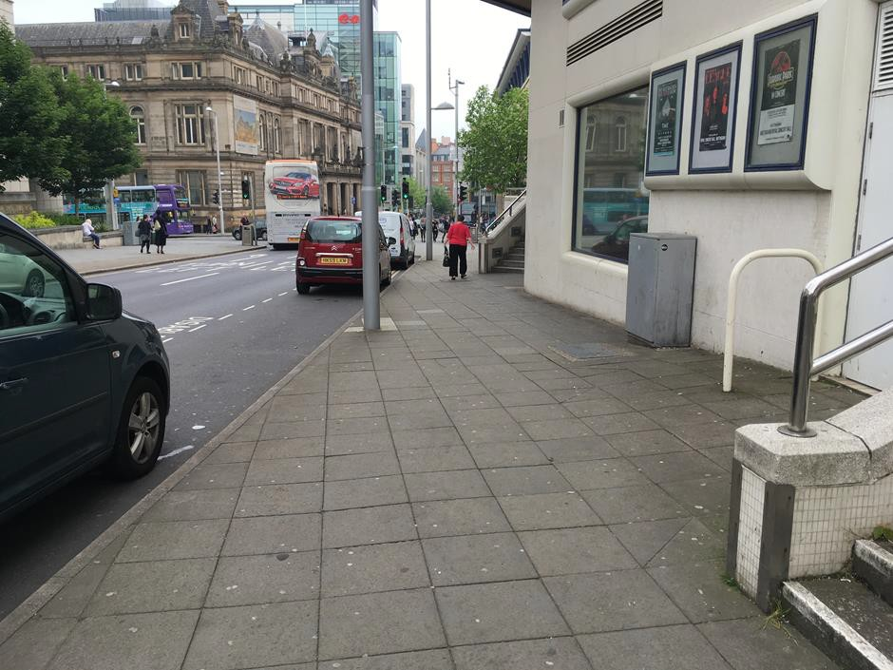
The Royal Concert Hall is 50 meters from Burton Street. The Theatre Royal is approximately 200 meters from Burton Street.

The blue badge parking spaces are next to the side of The Royal Concert Hall.

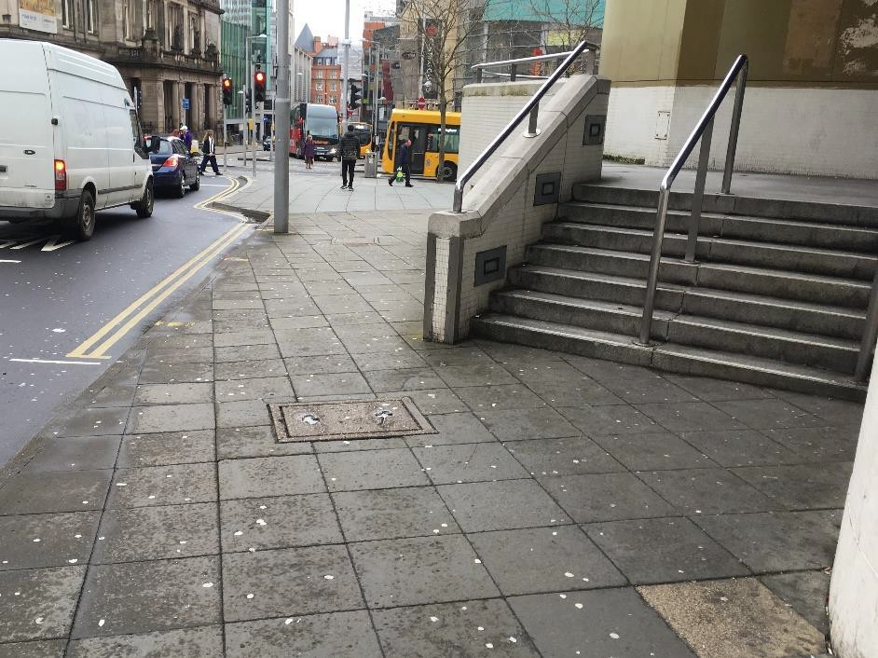
To get to the entrance of The Royal Concert Hall, walk down Burton Street, towards South Sherwood Street.

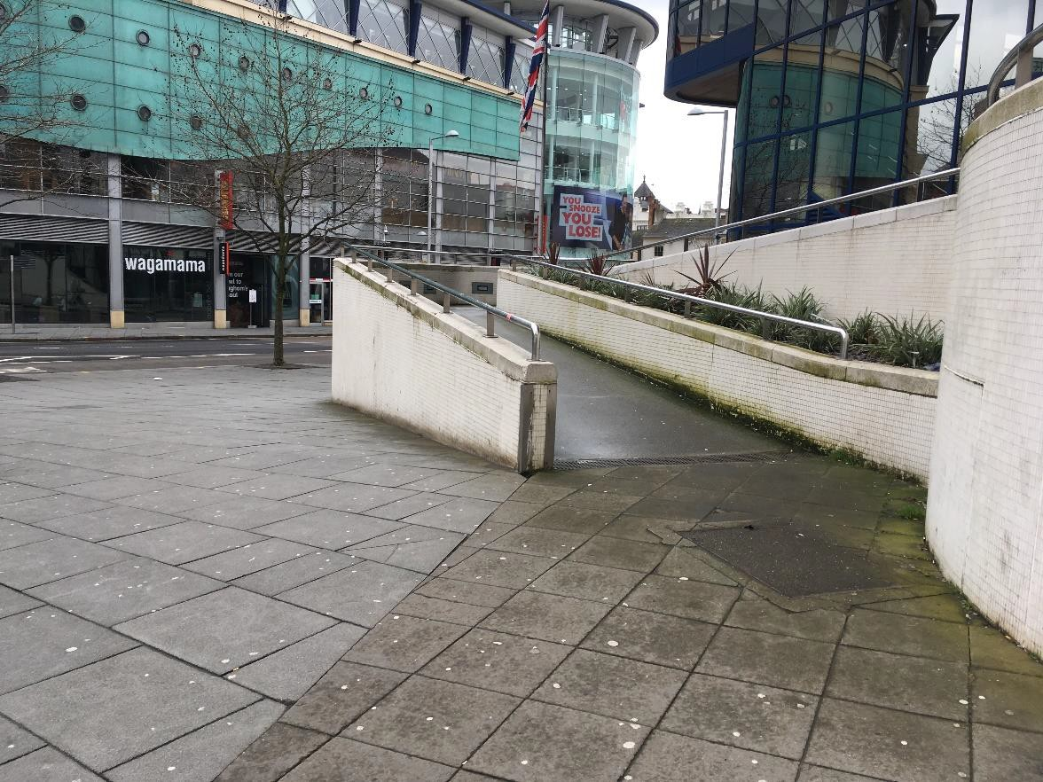
The ramped entrance to the Royal Concert Hall will be to your right.

Turn right onto South Sherwood Street.
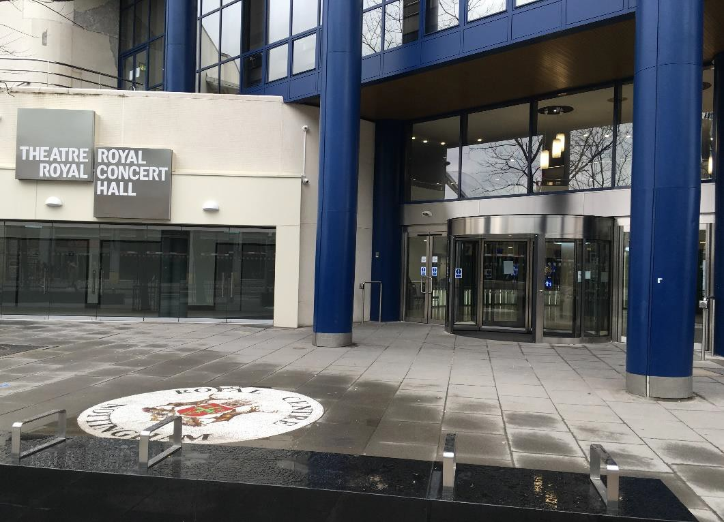
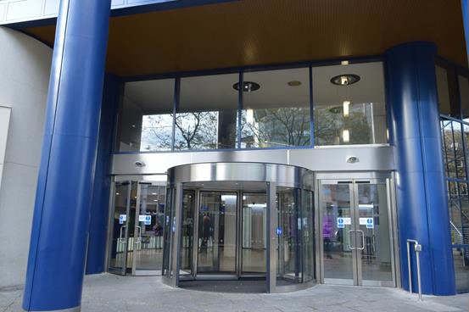
The entrance of the Royal Concert Hall is on South Sherwood Street.

To get to the entrance on the Theatre Royal, continue to walk down South Sherwood Street, past Yarn.
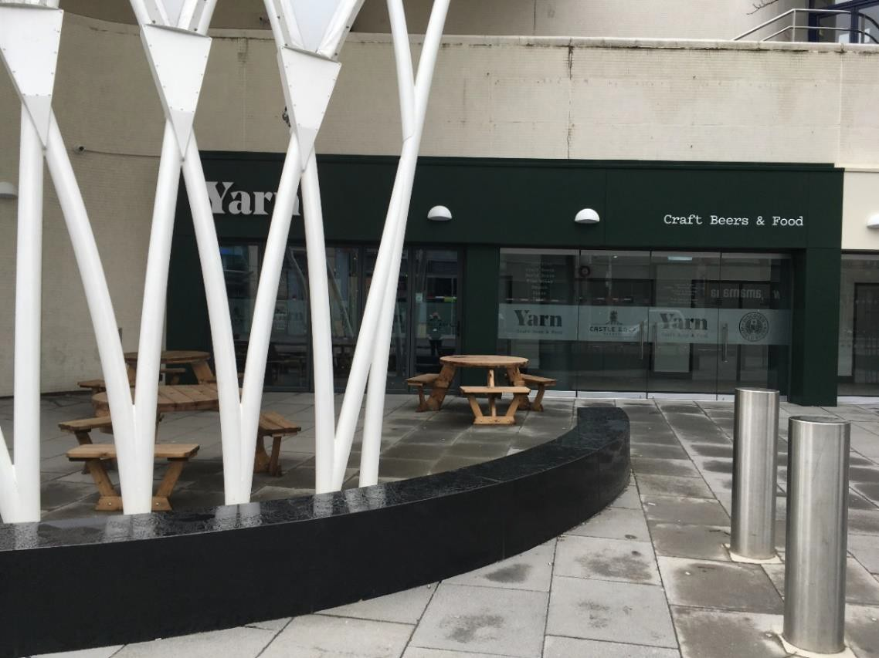
Turn right onto Upper Parliament Street.

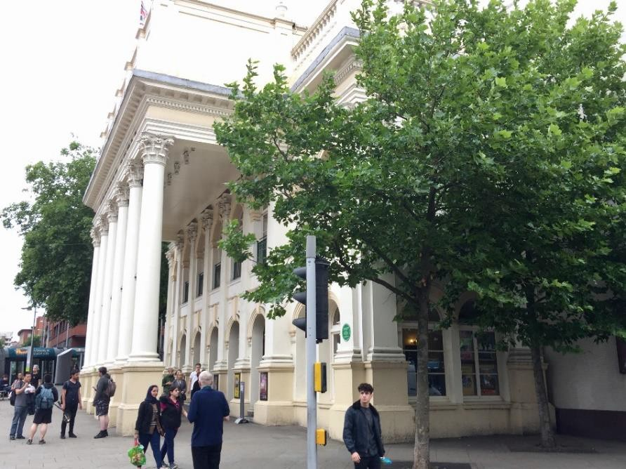

The entrance of the Theatre Royal is on Upper Parliament Street.
