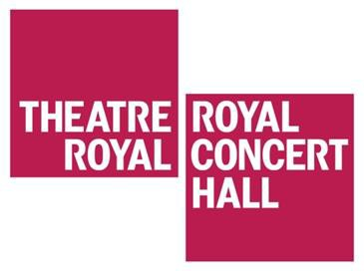

Visual story for travelling to the Theatre Royal and Royal Concert Hall Nottingham from Market Square

The Theatre Royal and Royal Concert Hall is 320 meters from the Market Square.
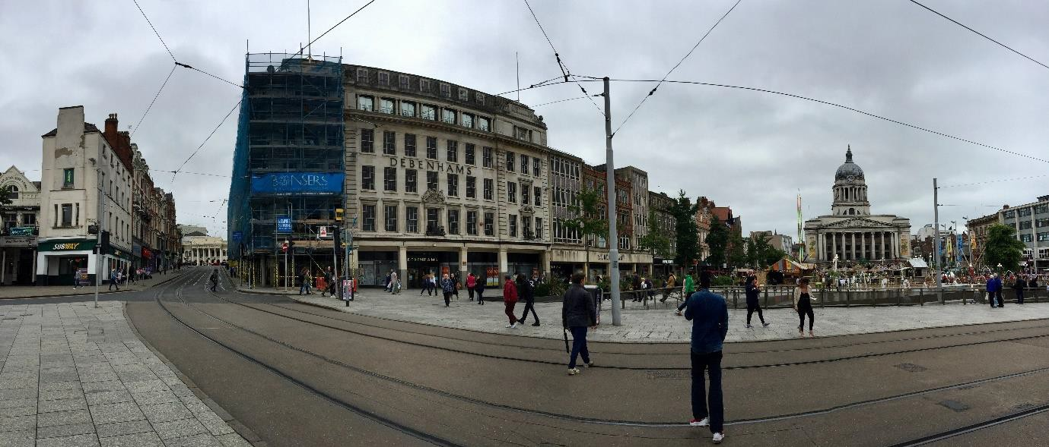
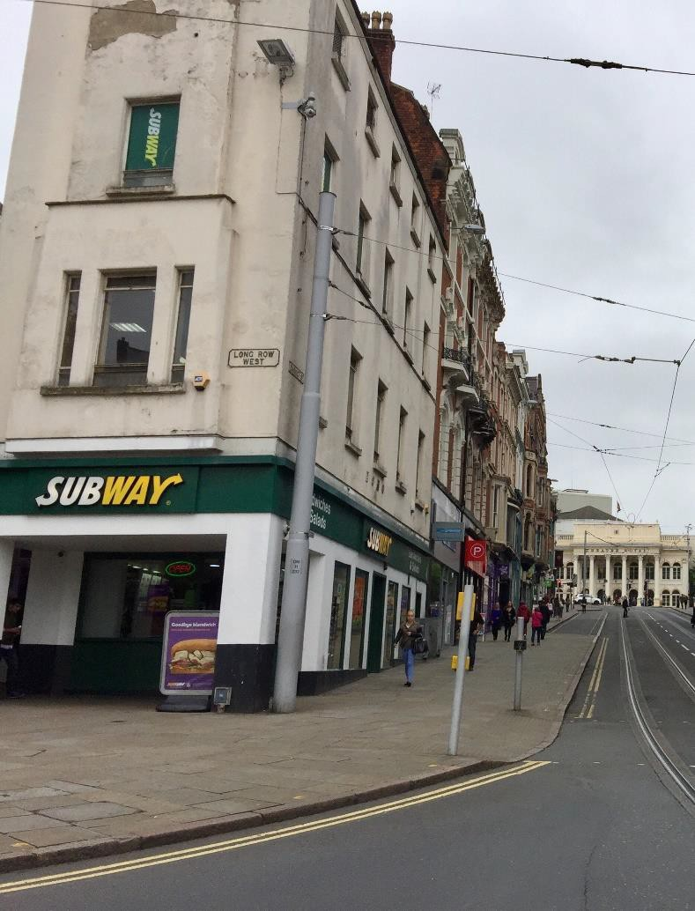
The front of the Theatre Royal can be seen from the end of Market Street.
From the Market Square, walk up Market Street.

Continue to walk up Market Street
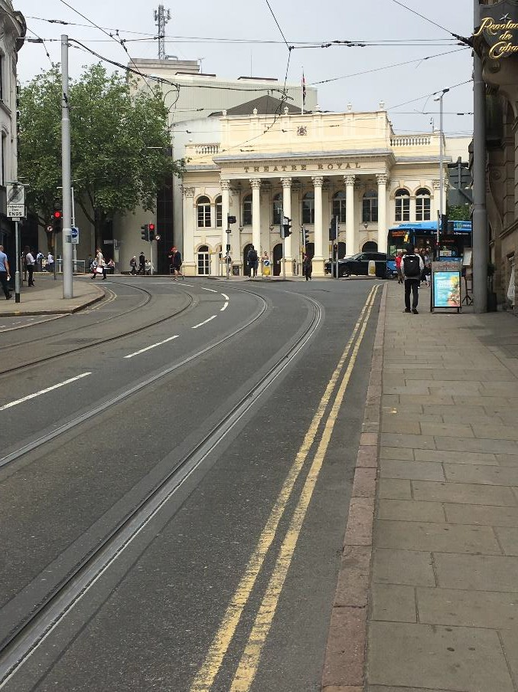
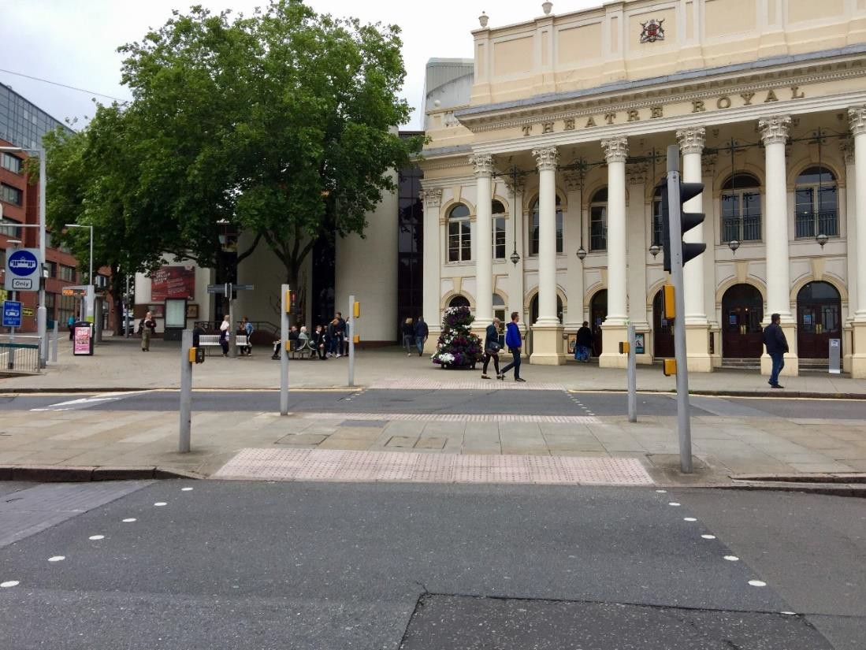
Use the pedestrian crossings to cross Upper Parliament Street

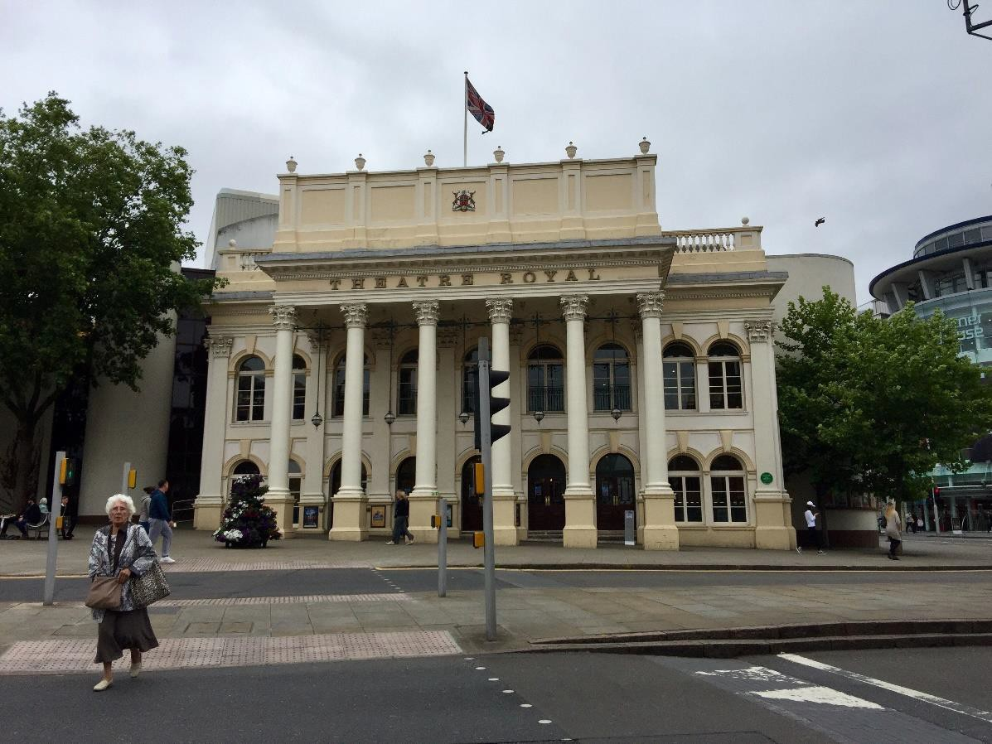
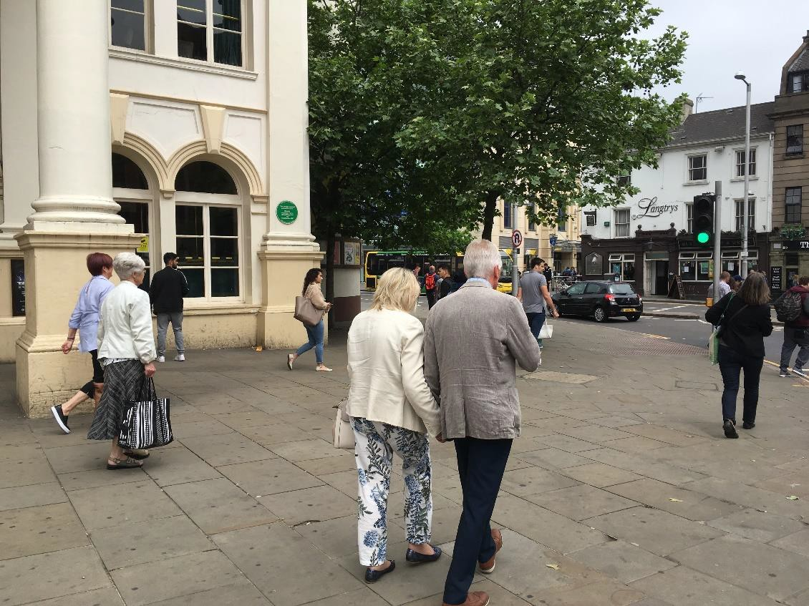
The entrance to the Theatre Royal is on Upper Parliament Street.

To reach the entrance of the Royal Concert Hall, walk down South Sherwood Street on the right hand side of the Theatre Royal.

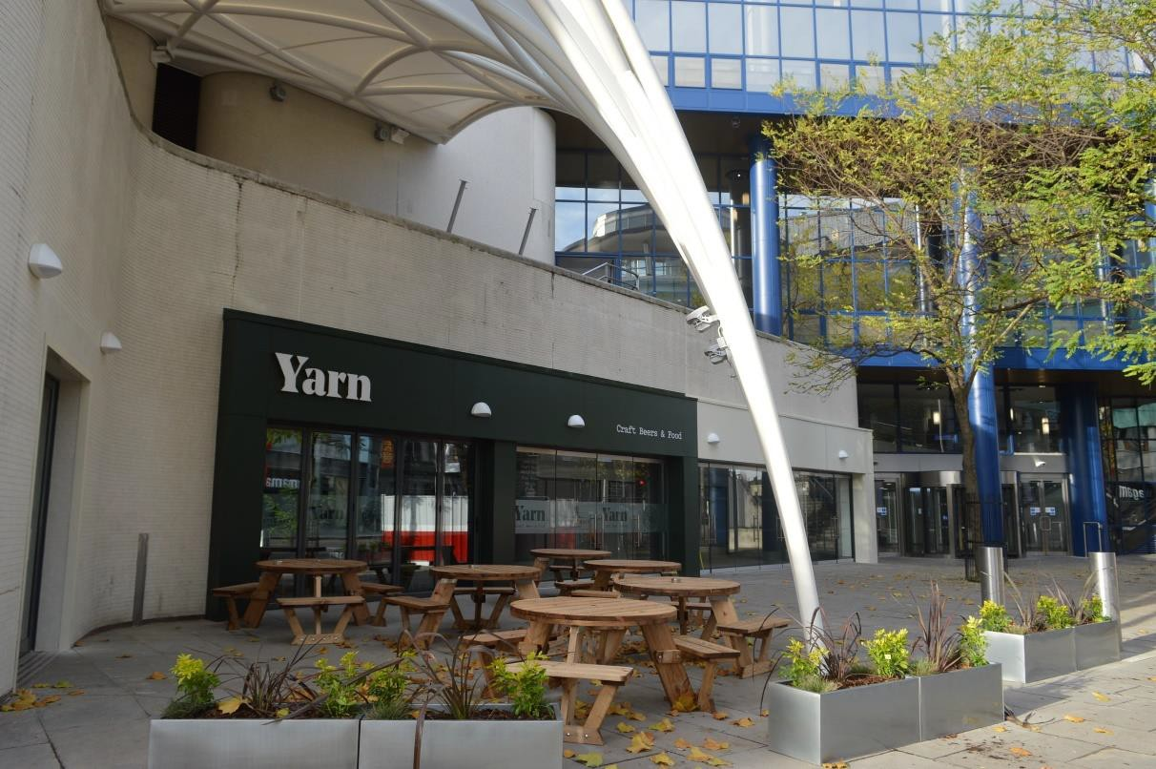
You will walk past Yarn.

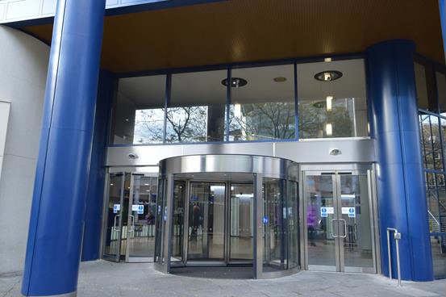
The entrance of the Royal Concert Hall is on South Sherwood Street.

