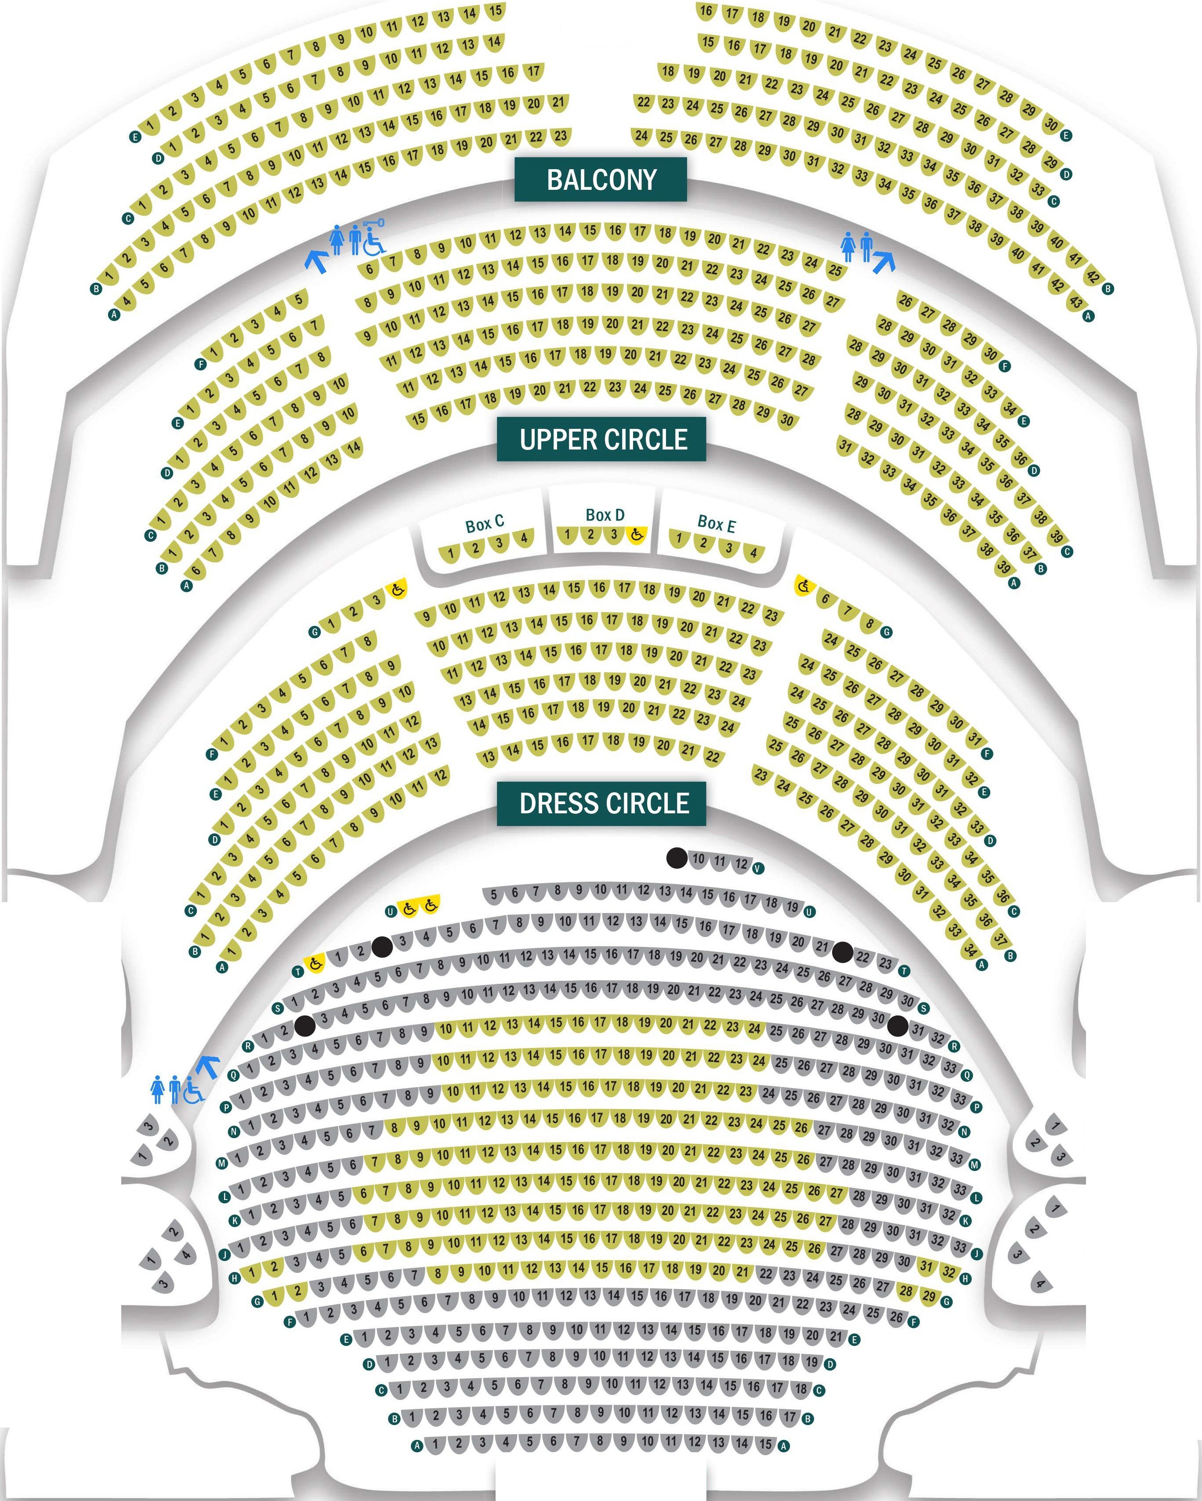
t-,t--
Stairs
TRCH.CO.UK 0115 989 5555

BoxA

BoxB
BoxF

BoxG




THEATRE ROYAL ROYAL CONCERT
HALL
STAGE

- Transmission blackspots
G.
STALLS

