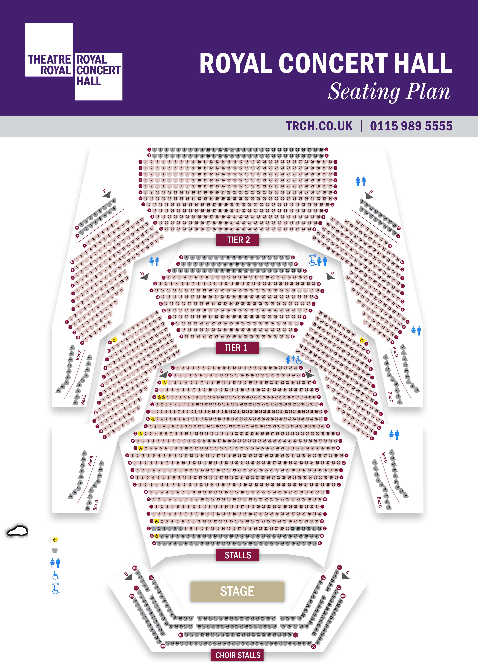






This seat can be removed to accomodate wheelchair space
Tramission blackspots Ladies & Gents toilets
Wheelchair accessible toilets Radar key accessible toilet

