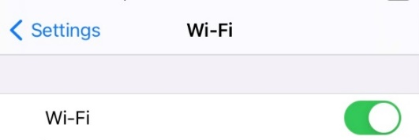
MobileConnect Quick Guide
In the Settings on your device, you need to connect to the correct wifi. Locate GovWIFI
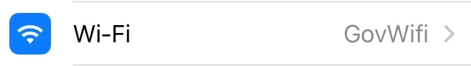
NB If you haven’t yet signed up to
use the GovWIFI – please refer
to the instructions of setting up a username and password as per either your Apple or Android device.
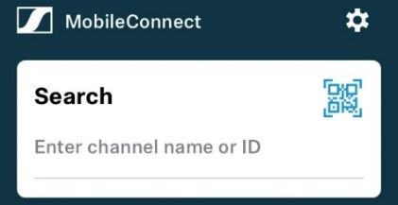
From the device’s home screen or app list, open the MobileConnect app. If you are connected to the right wifi, on the first screen of MobileConnect, you will see the option to Browse channels. Select the “Browse channels” in the venue you are visiting to to expand the channel list.
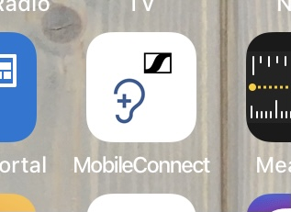

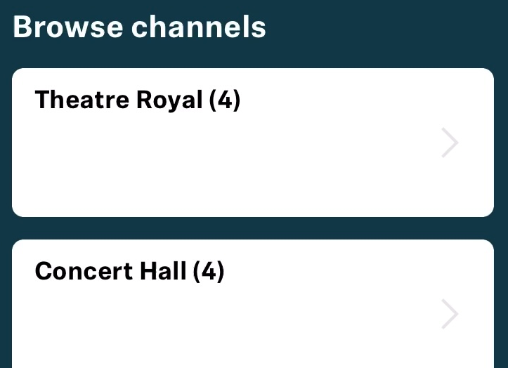
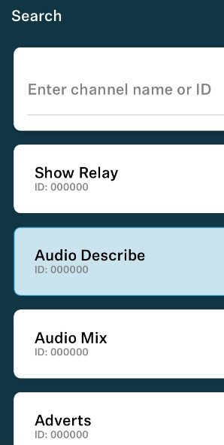
Different channels play different things:
Show Relay – Show relay (ie the sound coming through the microphones on stage). This is for customers not using the audio description, who just want to hear what’s happening on stage more clearly.
Audio Describe – The audio description as delivered by the Audio Describer live in the building.
Audio Mix – A combination of both the show relay and the audio description.
Adverts – Despite the name, this channel contains hold music. This is so the device can be tested at all times.

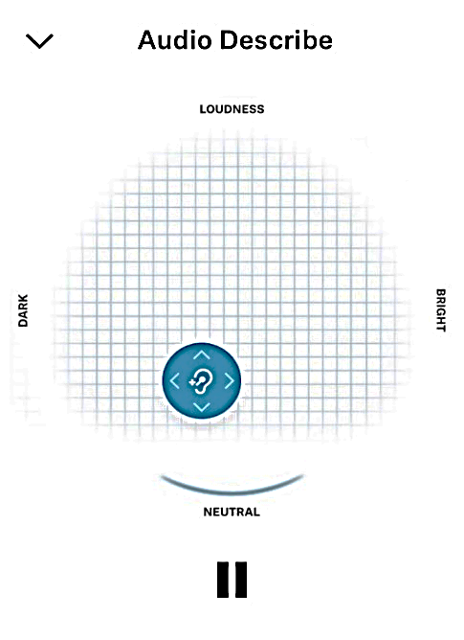
When a channel is opened, the phone/device will connect and you should hear sound.
The blue circle moves up and down for volume. It also moves left (softer) and right (brighter).
The phone/device also has a separate volume, which will also need to be turned up for you to hear anything.
The pause button mutes the sound.

POSSIBLE SCENARIOS | POSSIBLE SOLUTIONS
The first screen of the app does not display the channel list | Check the device is connected to correct wifi. If necessary, try entering the Settings (cog button in the app) and then click the Back arrow to return to the main screen to see if it updates itself  Alternatively try:  - Once you connected to the GovWiFi network  - Switch off the Wi-Fi on your phone.  - Open the Mobile Connect app.  - Switch the Wi-Fi back on  - Wait for Mobile Connect to recognise you are on the Wi-Fi and the channels should appear.
POSSIBLE SCENARIOS | POSSIBLE SOLUTIONS
The screen is too bright | Some versions of the app have a ‘dark’ mode that can be found in Settings>Display and Brightness>Dark Mode. Also, the phone/device should have its own brightness setting
The hearing aid/Bluetooth headset is receiving no sound | Check the volume on the phone/device. The Bluetooth on the phone/device may need to be reset
I have no Bluetooth hearing aids/headset | Many phones/devices can accept plugged in headphones - check if yours requires a standard audio jack or a lightning cable connection

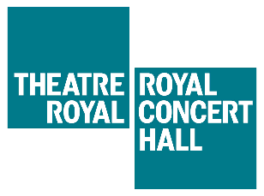
Public Wi-Fi

How to create a GovWifi account using your mobile phone
- *Text ‘Go’ to 07537 417 417. You may be charged by your mobile phone provider to send texts.
- You will then receive your unique username and password directly to your phone.

Connect via and Apple device
- Connect to ‘GovWifi’
- Enter your GovWifi username and password
- Select to ‘Trust’ the certificate
- Select ‘Accept’ below the Acceptable Use Policy
- You’re connected!

Connect via an Android device
- Connect to ‘GovWifi’
- EAP method – select ‘PEAP’
- Phase 2 Authentication – select ‘MSCHAPV2’
- CA Certificate – select ‘Do Not Validate’ (or if this option is not shown) select ‘Use system certificate’ then select ‘Do Not Verify’
- If it asks for a domain type in wifi.service.gov.uk
- Identify – enter your GovWifi username
- Anonymous identify – Leave blank
- Password – enter your GovWifi password
- Select ‘Connect’
- Select ‘Accept’ below the Acceptable Use Policy
- You’re connected!

You only need to complete the sign up once

Android screen for quick check reference:
